Hello Newsletter
Winter/Spring 2020, Greater Manchester
We are a charity that helps people living with sight loss and a range of other disabilities achieve their ambitions and go beyond expectations.
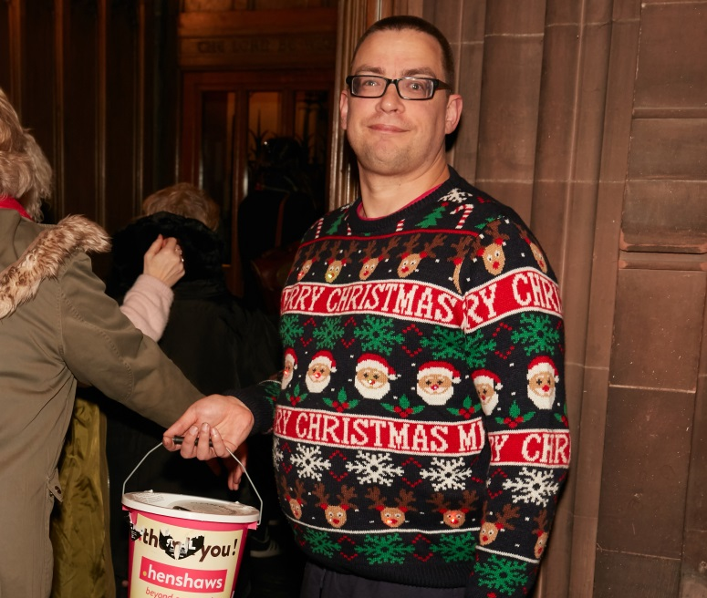
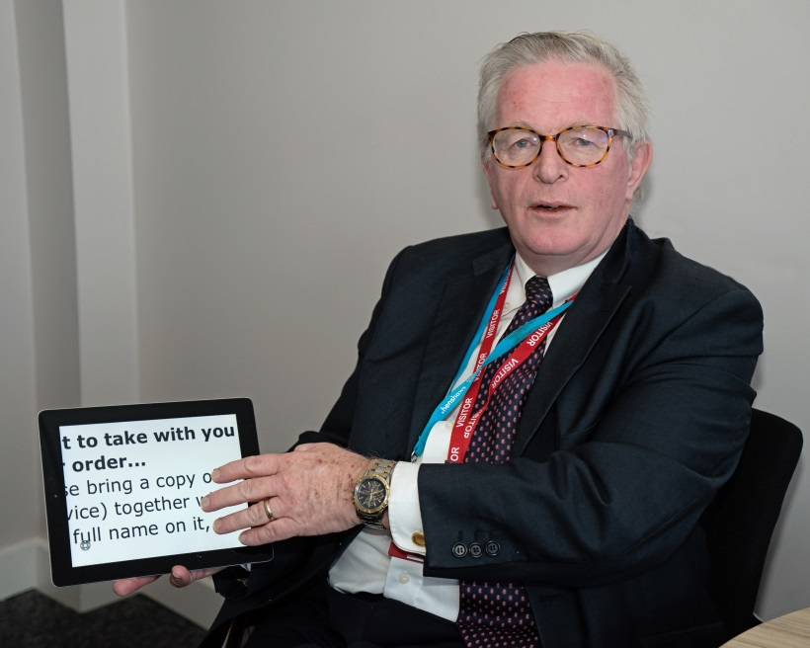

Henshaws, 4a Washbrook House, Lancastrian Office Centre, Talbot Road, Stretford, Manchester M32 0FP
Phone: 0300 222 5555 Visit: www.henshaws.org.uk
Contents
Page 2 Welcome message from Robert Cooper
Page 3 Community Services News
Page 13 Our Services
Page 17 Henshaws Knowledge Village
Page 18 Volunteer News
Page 18 Fundraising News
Page 21 Timetable of Groups and Activities
Page 25 Arts and Culture
Page 28 Other News

The photographs on the front cover shows two of our regular volunteers; on the left is Jim who helps our Digital Team carry out assessments and training at our headquarters each week, and on the right is Malcolm who regularly helps at our fundraising events and User Voice Group.

Hello and welcome to the winter/spring 2020 edition of Henshaws ‘Hello’ Newsletter.
“A very Happy New Year to all of our service users across Greater Manchester! We have a very exciting year ahead in 2020, the year of vision.
During the past three months we have supported 256 new people - 245 were people living with sight loss, 5 were healthcare professionals, and 6 were friends or family of people with a visual impairment. We delivered a total of 937 information, advice and guidance interventions, both over the phone through our First Step service and face-to-face with enablement staff in our community hubs. We also created 60 Personal Plans to help people on their sight loss journey, and carried out 88 digital assessments to help people access assistive technology. Overall, we now support a total of 7,019 visually impaired individuals!
We are currently busy working on an exciting new project called InSights. Every individual we work with at Henshaws is on their own personal journey with sight loss and has stories to tell from that journey. Disability can be incredibly isolating. As such relating to someone with lived experience is an important part of reducing isolation. This project enables us to facilitate peer to peer support digitally, by recording those stories and sharing them with our visually impaired community through our Knowledge Village resource. More details of this project will follow shortly!
I hope you find this newsletter informative; we always welcome your feedback.”
- Robert Cooper, Director of Community Services

Community Services News
Henshaws president honoured by the Queen
Congratulations to our charity’s President, Warren Smith, the Lord-Lieutenant of Greater Manchester, on becoming a Knight Commander of The Royal Victorian Order.
This photograph shows him standing at a lectern to deliver a reading at our carol concert at Manchester Cathedral in December. We are extremely proud and grateful to have Sir Warren as part of Team Henshaws!
Meet our new member of staff at the Bolton hub
“Hello, my name is Carlton Milenkovic and I am the new Community Enablement Officer for Bolton. I am responsible for providing people with support and guidance to improve their independence and confidence. In addition to supporting the Friendship Matters groups, I will be involved in developing and facilitating well-being programmes, such as the Living with Sight Loss course. I am really looking forward to being able to make a difference, by using a person-centred approach to help people gain confidence and access a thriving local community, which is something that really motivates me.
I’ve been a Martial Arts student and instructor for over 20 years, with a background in traditional Ju-Jitsu. I’m also an avid film fan, and proud supported of Bolton Wanderers!”

Henshaws news added to Talking Newspaper app
Wales, famous for Tom Jones, sheep, leeks and the recognised birthplace of Talking Newspapers in the UK. Talking newspapers first came to the UK in 1970 in the town of Aberystwyth in Wales. They were recorded onto cassette and initially distributed to twenty addresses in the Cardiganshire area. Almost 50 years later, there are over 500 local talking newspaper organisations across the UK and over 60,000 listeners.
During this time, as well as the expansion of Talking Newspapers, the technology has also moved on. Talking Newspapers were originally recorded onto cassette tapes (ask your mum if you don’t know what this is), then CD’s and more recently memory sticks. Now you can access some talking newspapers through an Echo skill or, more recently, by using the Talking Newspapers App.
The Talking Newspapers App has been developed by a collaboration between British Wireless for the Blind Fund and Talking News Federation. It gives access to over 200 Talking Newspapers from around the country, including Trafford, Stockport and Tameside, and this Henshaws Hello newsletter!
Talking Newspapers is available for free on iOS and Android. The app is very easy to navigate as it uses lists of options rather than icons. This means it is easy to navigate with just the basic Voice Over gestures, and it also works well with the largest font on Dynamic Text. To download, search for “Talking Newspapers” on Google Play or App Store. The Hello newsletter is in the North-West menu of available publications to listen to.

Invitation to a launch event in Sale
We would like to invite our service users along to a publicity event being held at the O2 phone shop in Sale. We now offer free digital assessments in the store every Friday, and we are inviting people to come in and find out more about the service on Friday 28 February between 1.00-3.00pm. Members of Henshaws staff will be on hand to demonstrate what we do during a digital assessment, and you can ask us any questions you may have about the rest of our services.
We look forward to seeing as many of you as possible at the event (did we mention there would be biscuits?!)

Anyone for golf?
Are you interested in joining a golf group for both visually impaired and sighted people?
Maybe you are a visually impaired ex-golfer who misses the opportunity to swing a club, make an occasional good shot, and the companionship and banter that comes from engagement in sport with like-minded people. Or maybe you might be someone who has always fancied having a go at golf but thinks the opportunity is not available to you as a visually impaired person? Whatever your eye condition, you can still learn how to play golf and enjoy the experience.
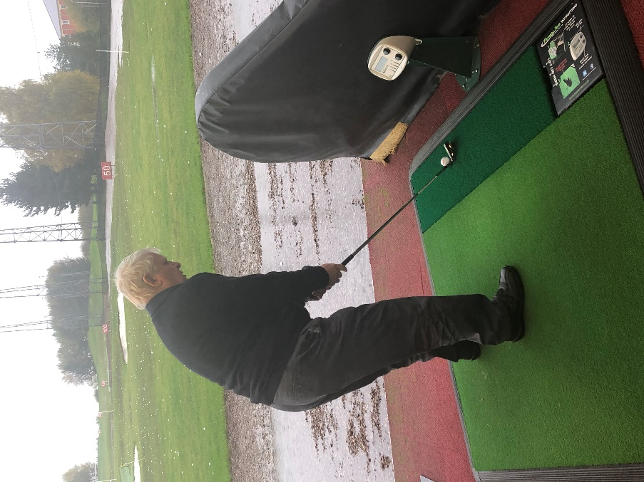
After I lost my sight some 9 years ago, I decided to do something about getting back into the sport. I found and joined a blind golf training course run by a local club professional who was also one of the British Blind Golf coaches. With the help and support of good friends and a sighted volunteer I enjoyed a number of years playing mainstream golf again alongside sighted friends on a regular course. The training must have worked as I achieved my first ever hole in one; in some 10 years playing the game prior to losing my sight this was something I had never achieved!
The challenges to playing golf fully with visual impairment include not only the time and commitment friends or volunteers need to commit to assist you, but also include the mobility to negotiate the course. There is an alternative which avoids these issues; I have found that going to a golf range with one of my friends provided me with much of the enjoyment of a full round of golf, but without the need to spoil a good walk or have to find my ball. We could still set targets and challenges and enjoy a good laugh and company.
I recently had the opportunity for a taster session at the Trafford Golf Centre with a few Henshaws staff and members. I had only previously been to the range a few times since moving to the area some years ago and had forgotten just how much I had enjoyed the experience.
I would like to know if there are sufficient visually impaired people, young or old, experienced or just enthusiastic, and of course any existing sighted Henshaws volunteers or any friends and family who might like to join a group to meet monthly to learn how to play blind golf. Have a laugh at everyone’s efforts and enjoy the company and support of other group members. One to one support is not necessary, although we will need some sighted support to assist visually impaired people as they take their turn in the golf bays. The good news for sighted volunteers is that they will be able to join in if they want!
The invitation is open to anyone across Greater Manchester. If you are interested, please let me know either by email on arthuraston@icloud.com or call me on 07884 251534. Once I have sufficient support to form a group, I will make arrangements with the range and let you know. The range assured us they will welcome and help in any way they can. I look forward to hearing from you.
Arthur Aston, Trustee and Group Leader
New support groups at Manchester Royal Eye Hospital
The glaucoma team at the Manchester Royal Eye Hospital are hosting meetings for patients who have glaucoma. The meetings are scheduled to run quarterly, and there will be guest speakers at each meeting from the glaucoma team. The dates for the rest of the meetings this year are as follows:
Wednesday 13 May, 1-3pm
Wednesday 9 September, 2-4pm
Wednesday 16 December, 2-4pm
If you would like to attend, please book a place by contacting our Patient Support Officer Gail at the hospital on 0161 276 5515.

We are also planning to organise a support group at the hospital in the future for patients with Charles Bonnet Syndrome. No dates have been set yet, but if you are interested in attending this group, please let Gail know at the hospital by calling 0161 276 5515 or email gail.brett@henshaws.org.uk

Together Vision working-age Friendship Matters group
The Together Vision group meet on the first Monday of every month, 6-8pm at the Friends Meeting House, Mount Street in Manchester city centre (a short walk from St.Peter’s Square tram stop). They have a schedule of themed sessions planned for the next six months: March – Advice session, April – Tech play, May – Sighted support, June – Chatty cakes, July – Dancing in the dark, and August – Summer trip.
If you require any further information, please contact Group Leader Nina on nina.chesworth@yahoo.com or join the Facebook group ‘Together Vision.’

Update from our Co-production Group
We are pleased to say that across the organisation we are strengthening our work in co-production; that is, involving service users in projects from design through to delivery. Examples include the development of the 7 Steps initiative, the new InSights project, website development and product testing.
If you would like to be involved and help with future projects, please contact Trustee Helen Brazier, through our First Step Team (telephone 0300 222 5555 or email info@henshaws.org.uk)

Charles Bonnet Syndrome art exhibition planned
We included an article in our previous newsletter about Joan, a service user from Tameside, who has created some wonderful artwork based on the hallucinations she has been experiencing due to Charles Bonnet Syndrome. We are pleased that we have been able to arrange an exhibition of this artwork at Neo in Manchester city centre; further details will be shared soon!

Not Quite Light Festival in Salford
We have been invited to work in collaboration with the organisers of the annual Not Quite Light Festival which takes place in Salford, from 26 to 29 March 2020. This arts festival will include a number of activities which are aimed at both raising awareness of sight loss, as well as raising vital funds for our charity. Events will include a Dinner in the Dark, a sponsored walk, and a special performance by some visually impaired people.
You can keep up to date with news about the festival on their website www.notquitelight.com

Special mention for one of regular hikers
Our ‘Henshaws Strollers’ Group Leader, Rob Lawley, would like to give a special mention to group member Joyce. Joyce still regularly joins in with the monthly planned walks across Greater Manchester at the ripe age of 95; this photo shows her enjoying the Christmas meal out in Sale with the rest of the Group (Joyce had walked the 3 miles to the pub after dosing up on painkillers due to her arthritis) Well done Joyce, keep on hiking!

Happy Appers tech support group
Happy Appers is a peer support group of visually impaired people, mainly, but not necessarily, drawn from the membership of the Trafford Tech Talk group. We meet monthly, on the 4th Thursday of each month, 1.00-2.00pm following the Tech Talk meeting which currently takes place in Sale.
The group share their collective skills and experience on a wide range of equipment, devices, accessibility software, and apps. Between us we cover most of the popular options, such as Microsoft, Apple, android, laptop, tablet and smart phone devices. We also have shared experience of smart speakers, media and navigation/mobility aids. and even hearing aids and smart TVs.
If a member of the group is considering purchase of new products, other group members are happy to share any relevant experience or views before a decision is made. We also help one another to develop our own skills, answer other members questions, and collectively make best use of products and services of interest to visually impaired people. If we are unable to assist, we can suggest where the answer can be obtained.
As a group we also focus on independence and accessibility opportunities available or coming to market and being developed for use by visually impaired people like ourselves. Over the past two years we have shared experience and assessed many of the products mentioned above for their ease of use and potential value to ourselves.
Membership of the group is open to anyone having some basic skills who wish to develop their awareness of product and independence opportunities, and are willing to share their own experience with others.
If you are interested in technology development, we strongly recommend you also consider joining a Henshaws Tech Talk group where new products and services are reported. Happy Appers may consider or assess some of these in more depth. Please contact us on 0300 222 5555 for further information or to arrange to attend a Happy Appers meeting. Another option is that providing you give us advance notice of your wish to attend a meeting, and a particular problem or skill issue you have, you would be welcome to attend a meeting on a drop-in basis. If we can assist you we will be happy to do so. We hope of course that your experience will persuade you to become a member of the group.

Events and news across our communities
Following the success of the first Visual Impairment Information Day in Oldham last year, another one will take place at Oldham Library on Monday 2 March 2020, between 10am-3pm. This will be an opportunity to find out more about a variety of services available in the area for people living with sight loss. We are looking forward to attending this event!
In conjunction with Oldham Leisure Services, a new group has been established called The Friday Club. The aim of the group is to reduce isolation and promote inclusion, as well as health and well-being. They meet each Friday from 10am-2pm at Oldham Leisure Centre on Middleton Road, and each session costs £3, with lunch included. The group takes part in a variety of activities, such as curling, table tennis, and carpet bowls, and from 11.15am group members can also access other services at the centre, including the gym and swimming pool. The sessions are for adults only, and carers are welcome to attend too. For further information, please call 0161 207 7000.
Our Chadderton Social Group that meets on the second Wednesday of the month is relocating to Barker Street Community Centre, Eden Street OL1 2XA from 11 March. The group meets from 10.30am-12.30pm, and everyone is welcome for a coffee, chat and friendship. The new venue is a very central location with excellent public transport facilities, and is only a few minutes’ walk away from the main bus station and the ICC building. We hope you are able to join us!

Social group members attend service user wedding
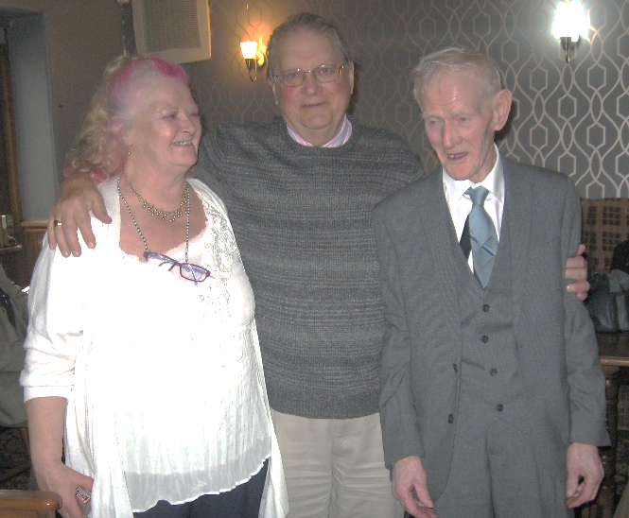
Huge congratulations to service user Michael Spotten, who married his partner Marlene in January. The special day in Gorton was attended by other members of the Tuesday Social Group; this photo shows the newly-weds with Group Leader Morris. Congratulations to the happy couple from everyone at Henshaws!

Our Services
Living with Sight Loss courses
We offer free, six session Living with Sight Loss courses, where you can explore what is available for people with a visual impairment, and also find out what is going on in your local area.
The courses we have planned over the next few months are as follows:
Bolton: 24 February – 30 March, 7 May – 11 June, and 3 August – 7 September
Oldham: 9 March – 13 April, 8 June – 13 July, and 14 September – 19 October
Tameside: 5 March – 9 April, 6 August – 10 September, and 29 October – 3 December
Dates are also being planned for both Wythenshawe and the Manchester Royal Eye Hospital. We are also running a special two session Living with Sight Loss course for stroke survivors on 13 and 20 April at our Bolton hub.
If you are interested in attending a course, please get in touch with our First Step team (call us on 0300 222 5555 or email info@henshaws.org.uk)

Patient Support service at eye hospital locations
Gail works as our Patient Support Officer at the Manchester Royal Eye Hospital, and she has written this short article:
“I have had the pleasure of meeting many of you when you have been attending your appointments at the eye hospital. If you are a patient at MREH and would like to come in and see me, I am here from Monday to Friday 9-4pm. I’m here to offer both practical and emotional support for anyone with sight loss, and their friends and families too. Some of the main things I can assist with are discussing support and services which may be available in your local area; advising about the certificate of vision impairment process; arranging a low vision assessment for magnifiers; support in your appointments; and information on your eye condition.
My office is on the ground floor of the eye hospital, between clinic G and the emergency eye clinic, if you would like to pop in and see me. If you have a general query or would like a little bit of advice you can also contact me on 0161 2765515 or send me an email on gail.brett@henshaws.org.uk”
Did you know that we also offer a Patient Support Service at Altrincham Hospital from 9.00am to 4.30pm on Mondays and Tuesdays? Our new Patient Support Officer, Sue Clarke, is there to provide information, advice and guidance about anything relating to sight loss for patients, their friends and families. Sue also provides emotional and practical support, support during appointments, and advice on local services.
We are also lucky to have a fantastic Henshaws volunteer at Altrincham Hospital; from 10.30am to 12noon on Tuesdays, you will find Ian on the first floor of the main waiting room ready to assist you.

Children and Young People’s Service
Our Children and Young People’s (CYP) Service team in Greater Manchester and Merseyside specialise in working with children and parents with sight loss, offering information, advice and guidance, and practical and emotional support.
Our families receive their own dedicated CYP newsletter and can keep up to date with all our events in our Facebook groups.
Please call on 0300 222 5555 for more info about the services we offer to young visually impaired people and their families.

Counselling service
It can be difficult to come to terms with being diagnosed with sight loss. It’s perfectly normal to feel overwhelmed, but it can help to have someone to talk to who can empathise and help you process the many emotions you can feel after your diagnosis; that's why we offer counselling across Greater Manchester.
Our Community Counsellor, Deborah Haydock, offers both face-to-face and telephone sessions for those unable to physically attend one of our venues. We are currently operating a waiting list; please contact us on 0300 222 5555 for more details.

Digital services
We provide one-to-one digital assessments and training at various locations across Greater Manchester, where we can assess your needs and make suggestions on the best solutions for you; no matter what your sight level, age, or technical ability is. The products we offer our expertise on include Apple, Synapptic, OrCam, JAWS and much more. These take place at Manchester Central Library, Bolton, Oldham, Tameside and Trafford.
If you would like to book an assessment, please call our First Step team on 0300 222 5555 or email info@henshaws.org.uk

Skills for Seeing training
This might sound like we are teaching granny to suck eggs, but did you know there is more than one way to use a magnifier? Did you know that there are some basic techniques that can improve your reading experience?
We are working with the Macular Society to try and improve the experience of reading for those who have macular degeneration. The Skills for Seeing project involves assessing the way you currently read and exploring techniques that can be used to make reading easier, faster and more fluent. This includes positioning, lighting and a couple of different techniques.
Steady Eye Strategy examines the way that you move yourself, your magnifier and the item you are reading. Eccentric Viewing involves finding the strongest area of your vision so that you can maximise the effectiveness of your remaining vision.
If this sounds like something you would like to know more about, please get in touch with our Digital Team by calling 0300 222 5555 or by email on info@henshaws.org.uk

Henshaws Knowledge Village
Henshaws Knowledge Village continues to grow with new content, including videos on the Nest security system, the experience of one our service users with the Social Care Ombudsman, and how to use an iPhone when you have a visual impairment.
Please make sure you visit our Knowledge Village to explore our valuable resources and learn everything about apps and technology to Life Hacks at www.henshaws.org.uk/knowledge-village. You can also subscribe to our YouTube channel at www.youtube.com/user/Henshaws1837.
During the month of December alone we had 5,828 views on our YouTube channel, and people accessed our website content in countries as far away as India and Hong Kong!
If you would like to receive monthly e-mails so you can keep up to date with new content on our Knowledge Village, make sure you join our mailing list through the website at www.henshaws.org.uk/sign-up-knowledge-village. If you have any ideas of features you would like us to cover in a video, blog or eBook, please do get in touch with us on 0300 222 5555 or email info@henshaws.org.uk as we’d love to hear your ideas!

Volunteer News
If you are interested in volunteering at any fundraising events, would like to help at one of our social/hobby groups across Greater Manchester, provide information to visitors at our demo desk at the eye hospital in Manchester or Altrincham hospital, or drive our visually impaired service users to and from Henshaws activities, please do get in touch on 0300 222 5555. Thank you.

Fundraising News
Challenge events
Do you or a family member or friend want to take on a challenge in 2020? Why not take it on whilst also raising money for Henshaws! We have charity places for various events, or you can enter yourself into another one you want to do and still raise funds for Henshaws. So whether you want a charity place or you have a place of your own give the Fundraising Team a call on 0300 222 5555 and let us know!
If you fancy a running event why not take on the Great Manchester Run on 24 May 2020? The Great Manchester run is the nation’s favourite 10K running event, popular among world class athletes and beginners alike. With its party atmosphere, bands spotted on various parts of the route and the amazing crowd support that almost rivals the crowds during the London Marathon, the Great Manchester Run event is perfect for those who simply want to jog along as well as those trying to run as fast as they can. The course passes the iconic Old Trafford football stadium and finishes right in the heart of this fantastic city. It also has a Half Marathon option as well if 10K isn’t challenge enough for you!
For those of you who would rather take on a walking challenge, why not take on the Yorkshire Three Peaks on 18 July 2020? Walking 24 miles within 12 hours amongst some of Yorkshires famous scenery, you will take on Yorkshire’s three highest peaks, Whernside, Ingleborough and Pen y Ghent, ascending more than 1700 metres. You will be guided through the beautiful countryside in groups by a trained guide. With a fundraising target of only £100 this Challenge appeals to both those who want a ramble through the countryside, and those who want more of a challenge.
Dave, a Henshaws service user with less than 5% sight who walked the length of Britain fundraising for Henshaws, says: “I love taking on challenges, it’s a huge positive that I can raise awareness of what blind people can do! It felt great to raise so much money for Henshaws as I’ve benefitted hugely from their support.”
If you would like more information on Challenge Events or would like to enter any of the events mentioned please call the fundraising team on 0300 222 5555 or email Kat Parry, Individual Giving Fundraiser, on Kat.Parry@henshaws.org.uk
We need your help!
We are currently searching for service users who are willing to share their experiences of Henshaws for fundraising and marketing purposes. Whether it is just providing us with a quote, or answering some questions and having your photograph taken, we really need your help! Reading stories and experiences about our service users are the reason that people support our charity.
If you would like to help us in this way, please contact Alex Blythe on 0161 786 3662 or email alex.blythe@henshaws.org.uk

The Henshaws Lottery
Did you know that we run a Henshaws Lottery? Every £1 spent on the lottery will ensure that 51p goes directly towards helping people with sight loss in Greater Manchester to receive much-needed support, friendship and training. If you are interested in playing our lottery for as little as £1 every week, with a chance to win £25,000, please call us on 0300 222 5555 or sign up at www.henshaws.org.uk/charity-lottery

Keep in touch with the Fundraising team
If you would like to hear more about fundraising and volunteering opportunities with Henshaws, you can be added to our dedicated mailing list. Contact us on 0300 222 5555 or email fundraising@henshaws.org.uk to sign up today!

Timetable of Groups and Activities
Did you know we have over 20 different groups and classes currently running across Greater Manchester? Whether you’d like to find out about new technology, join an exercise class, or just meet people, we have a wide range of groups for you to try. Please note that times/dates/locations may be subject to change. If you would like to know more details about any of these listings, please get in touch with us on 0300 222 5555.

Bolton
Braille Group (Bolton) - The Sensory Centre, Tonge Moor
Tuesdays (weekly), 1.00-3.00pm
Luncheon Club - The Sensory Centre, Tonge Moor
Wednesdays (weekly), 10.30am-1.30pm
Afternoon Tea - The Sensory Centre, Tonge Moor
Thursdays (fortnightly) 12.30-1.30pm
Tech Talk - The Sensory Centre, Tonge Moor
First Thursday of the month, 10.30am-11.30am

Manchester
Coffee Morning - Wythenshawe Forum café
Second Thursday of the month, 10.30am-12.30pm
Together Vision Group – Friends’ Meeting House, Mount Street
First Monday of the month, 6.00pm-8.00pm

Oldham
Monday Clubbers - St Pauls Court, Ashton Road, OL8 1UX
Mondays (weekly), 2-4pm
Opportunity for a coffee and a natter, to make new friends, and experience regular speakers and activities.
Braille Group - Oldham Lifelong Learning Centre, Greaves St.
Tuesdays (weekly, term-time only), 9am-12noon
A chance for people to learn braille from scratch or refresh their skills! Group is run in conjunction with Oldham Council.
Royshaw Vale Social – Downy House, Church Street, Royton
Tuesdays (weekly), 10am-12noon
Fun, friendship – a friendly and warm welcome guaranteed!
Chadderton Social - St Herbert’s Court, Chadderton
Second Wednesday of the month, 10am-12pm
People are welcome for a coffee, chat and friendship! Please note that from 11 March, this group will be re-locating to Barker Street Community Centre, Eden Street from 10.30am-12.30pm.
Macular Support Group – The Link Centre, Oldham, OL1 1DZ
Second Wednesday of the month, 1-2.30pm
Tech Talk – Positive Steps, Oldham
Fourth Wednesday of the month, 10.30am-12.30pm
Pennine Vale Social - Sacred Heart Centre, Uppermill, OL3 6HS
Third Friday of the month, 10.30am-12.30pm
Always a warm welcome at this group, plus delightful cake!

Salford
Broadwalk Social Group - Pendleton Gateway, Salford
First Tuesday of the month, 10.30am-12.30pm
I Spy Social - Rainbow Rooms Community Centre, Eccles
Tuesdays (fortnightly) 2-4pm
Eye Eye Social - Wardley Community Centre, Swinton
Wednesdays (weekly) 12.30-2.30pm

Tameside
Coffee morning – Wellington Parade, Dukinfield
First Tuesday of every month, 10.30am-12.30pm
Information, advice & guidance – Wellington Parade, Dukinfield
Mondays, Tuesdays and Thursdays (weekly), 9.00-4.30pm
Friday Social Group – Wellington Parade, Dukinfield
Fridays (weekly), 10.30am–1.00pm
People are welcome for a coffee, chat and friendship!

Trafford
Coffee morning – Tesco café, Altrincham
Last Monday of the month, 10.30am-12.30pm
Yoga – Trafford House, Chester Road, Stretford
Tuesdays (weekly), 12noon-1.30pm
Unwind with the ancient form of exercise, to improve balance, lower body strength, and boost physical and mental wellbeing.
Tuesday Social - Avenue Methodist Church, Sale
Tuesdays (weekly), 1-3pm
A chance to chat with other people living with sight loss; enjoy a range of activities, including bingo, quizzes and music.
Happy Appers – Avenue Methodist Church, Sale
Fourth Thursday of the month, 1.00pm-2.00pm
Tech Talk – Avenue Methodist Church, Sale
Fourth Thursday of the month, 10.30am-12.30pm
Arts and Crafts Group – Avenue Methodist Church, Sale
Fridays (fortnightly), 1.15-3.15pm
For anyone who would like to try a variety of arts and crafts, including painting, tactile pictures, and model making; be creative in a relaxed environment!
Braille Group - Stretford Library
Fridays (weekly), 10am-12noon (drop-in)
Friday Social Group – Stretford Library
Fridays (weekly), 10am-12noon (drop-in)

Across Greater Manchester
Henshaws Strollers (location varies each month)
First Thursday of the month, 10.00am-4.00pm approx.
A great way to stay active, explore the local landscape and meet new people, and there is usually a stop off at a pub for refreshments and a well-earned rest!

Art Galleries and Museums Group (location varies each month)
The Group meets on Thursday once a month at a variety of Museums and Galleries across Greater Manchester. Group Leader Mary Gifford takes an escorted group to a museum or gallery event, which includes audio description and sometimes a touch and handling element, and is an ideal way for blind and visually impaired people to appreciate the arts. The events end with refreshments and time for a chat.
Future visits (all dates, details and venues to be confirmed):
Thursday 19 March
Thursday 9 April
Thursday 21 May
Thursday 25 June

Arts and Culture

Audio Described Events – March 2020 to June 2020
The list below has been compiled from information provided by Anne Hornsby of Mind’s Eye Professional Description Service, The Lowry and Vocaleyes. Most theatre performances include a touch-tour about an hour before the performance; you can check with the Box Office or Mind’s Eye for details. Ticket prices, including concessions, and seat and headset bookings can also be made in advance through the Box Office. Most theatres offer special prices to blind and visually impaired people, so please enquire at the Box Office.
March
5 19.30 4 Minutes 12 Seconds Oldham Coliseum
7 14.00 Swan Lake (B’ham Royal Ballet)The Lowry
7 14.30 Beautiful Bradford Alhambra
12 19.00 Marriage of Figaro (Opera North)The Lowry
13 19.30 Insane Animals HOME
16 17.30 AD tour of Talking Sense Portico Library
24 19.30 Happy Days Bolton Octagon
25 19.30 Acosta Danza The Lowry

April
4 14.30 Rockets and Blue Lights Royal Exchange
11 14.30 What’s in a Name Bradford Alhambra
15 19.30 Jungle Book Oldham Coliseum
30 19.30 Back to the Future Opera House

May
14 20.00 Thank You for Doing Nothing The Lowry
16 20.00 I think we are alone The Lowry
19 19.30 Phantom of the Opera Palace
23 14.30 West Side Story Royal Exchange
26 19.30 Les Miserables The Lowry

June
4 14.00 The Lion King Bradford Alhambra
6 14.00 Cinderella (Northern Ballet) The Lowry
18 19.30 Shandyland Oldham Coliseum
27 14.30 The Glass Menagerie Royal Exchange

Useful telephone numbers:
Mind's Eye 01204 522481 or 07889 232 438
Bolton Octagon 01204 520 661
HOME 0161 200 1500
Oldham Coliseum Theatre 0161 624 1731
Palace Theatre & Opera House, Manchester 0161 245 6605
Portico Library 0161 236 6785
Royal Exchange Theatre, Manchester 0845 450 4808
The Lowry 0161 876 2183
Bradford Alhambra 0127 443 2000
VocalEyes 0207 375 1043

‘Making Conversation Workshops’ at Manchester Art Gallery
These lively and sociable workshops are led by artist Naomi Kendrick and supported by audio description. They are open to everyone and take place on the last Tuesday of the month (except December) from 1pm-4pm. Each session starts with a question which is explored through an exhibition visit, talking and making activities.
Materials and refreshments are provided, and Manchester Art Gallery may be able to help with travel costs/arrangements by contacting them on 0161 235 8840 or email nicola.colclough@manchester.gov.uk – if you do not require transport, there is no longer any need to book. Just come to the gallery on the day of the session and ask at the information desk. Forthcoming dates are 31 March, 28 April, 26 May and 30 June (all 1-4pm).

Audio Described Tour at The Portico Library
On Monday 16 March at 5.30pm, Anne Hornsby will be describing the exhibition “Talking Sense: The changing vocabulary of mind and brain.”
The vocabulary we use to describe mental and emotional experience is changing. With attitudes shifting towards compassion in policy and treatment, terms such as well-being, recovery and mental health are being re-examined, and their connotations questioned.
In this exhibition, 50 artworks are paired with 50 phrases created by jumbling the contents of the textbook ‘Diagnostic and Statistical Manual of Mental Disorders’, first published in 1952. By this process, the exhibition hopes to open up a space for helpful conversations around the future of care.
The main entrance to the library is on Charlotte Street at the corner with Mosley Street. There is an intercom button next to the door and the library is up several flights of stairs. As a Grade II* Listed Building the Library does not yet have fully step-free access, but if you would like to use the stair-lift please tell a member of staff who will give you directions to the more accessible entrance.

AD theatre shows at HOME - £1 Inspire tickets Offer
HOME is Manchester’s centre for contemporary theatre, film, art, music and more. It is located on the pedestrianised First Street, a short walk from Oxford Road and the Deansgate-Castlefield Metrolink stop (Tony Wilson Place, Manchester M15 4FN).
HOME are offering Audio Described theatre shows for the reduced rate of £1, with a limited number of tickets per show on a first-come, first-served basis. They also provide a Touch Tour and essential companion tickets. HOME’s AD theatre shows are included in the Audio Described Events Listing.
To book, call Marisa Draper on 0161 212 3453 or email marisa.draper@homemcr.org. Please say you are from Henshaws and that you are booking Inspire tickets for the Audio Described show.

Other News
SAVI support group in Bolton
Are you feeling isolated due to your eye condition? Come along and meet new friends at the VIP Saturday Social at The Sensory Centre at Thicketford, Bolton. They meet each Saturday from 1pm-6.30pm; £5 gets you a freshly cooked, two course meal and unlimited refreshments, and you can also enjoy many activities, including bingo, quizzes, dominoes, trips out and much more.
For more information, contact Pauline on 07968 815509 or email savibolton@gmail.com

Volition Community Project
If you are out of work and looking for something to improve your odds of finding a good job, then Volition may be just for you. We are a small project, established by Manchester Cathedral, to help people find work. We offer volunteering opportunities alongside group work to help everyone achieve their potential. Each free group runs for 10 weeks, but some people find themselves staying much longer as they connect with new friends.
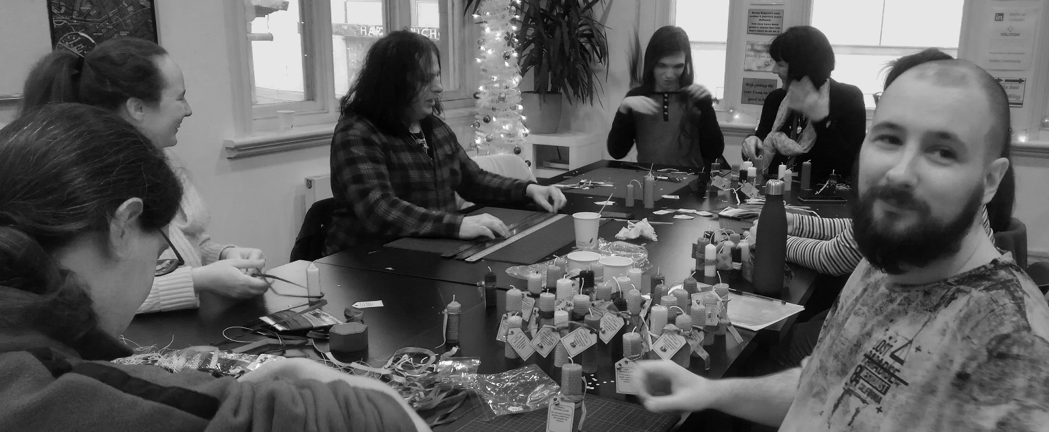
Kyle started volunteering with Volition last spring. He has Leber’s Hereditary Optic Neuropathy, which means his vision has been deteriorating since the age of sixteen. Kyle says; “I heard about Volition through my work coach at the job centre. I was feeling low at the time and needed something new. I was the only one in my group with sight loss but was thoroughly welcomed. I chose to volunteer with the beekeepers and also as a Cathedral welcomer. Despite my mental health and sight loss, I overcame my fears and helped take the hives apart and on different days welcomed people to the Cathedral. I have enjoyed every moment, made good friends and recently went back to make candles. I would recommend Volition to anyone!”
Information sessions are held every month in the heart of Manchester. For more information please call 0161 833 2220 or email info@volitioncommunity.org

Salford Talking Newspaper
Salford Talking Newspaper has been providing an audio version of local news to visually impaired people in Salford for almost 40 years. Each week they record, copy and distribute an audio version of local news on a USB digital memory stick, which can be played on a digital player unit that is provided free of charge on a permanent loan basis. For further details, please call 0161 736 8670 or email admin@salford-talking-news.org.uk

Recruitment for Sight Loss Council
Sight Loss Councils are being set up across the country. They exist to make our cities and towns more accessible for blind and partially sighted people and only have visually impaired volunteers from their local areas sitting on them. Sight Loss Councils are not a talking group, they are a ‘doing’ group and actively engage with local stakeholders to improve services; already they are making a great difference to the lives of many.
We are in the process of recruiting to form a Greater Manchester Sight Loss Council. If you would like to get actively involved and require more information, then please contact Iain Mitchell at iain.mitchell@pocklington-trust.org.uk or call 07914770909. Thank you.

A final word from the Hello newsletter editor
We hope you have enjoyed reading this newsletter; if you have any suggestions about new features we could include, please contact me as I would love to hear from you! Call Sarah Mollitt on 0300 222 5555 or email sarah.mollitt@henshaws.org.uk.
Once you have read or listened to our newsletter, please pass it on to a friend or family member; or you could enquire at your GP, church or library to see if you could leave it there for others to enjoy.
Similarly, if you would like any leaflets or posters about our services to give to friends or family members, or you attend a local community venue that wouldn’t mind a poster being put up, please contact me and I can send you some relevant material.

Where to find us
Our hubs are spread across Greater Manchester:
Altrincham Hospital - Railway Street, Altrincham WA14 2RE
Bolton - The Sensory Centre at Thicketford, 336 Ainsworth Lane, Bolton BL2 2QL
Manchester Royal Eye Hospital (MREH) - Oxford Road, Manchester M13 9WL
North Manchester – Venue to be confirmed
Oldham - Medtia Place, 80 Union St, Oldham OL1 1DJ
Salford - Room 2, Pendleton Gateway, Salford M6 5FX
Tameside - 3-4 Wellington Parade, Dukinfield SK16 4LE
Trafford – Venue to be confirmed
Wythenshawe - Wythenshawe Forum, Simonsway, Wythenshawe M22 5RX

Facebook: www.facebook.com/Henshaws
Twitter: www.twitter.com/Henshaws
Instagram: www.instagram.com/henshaws_uk

Disclaimer
Although every attempt is made to ensure that the information contained within this newsletter is timely and accurate, Henshaws cannot be held responsible for any information herein. This newsletter is provided for information purposes only and is not intended to be either legally binding or contractual in nature.

