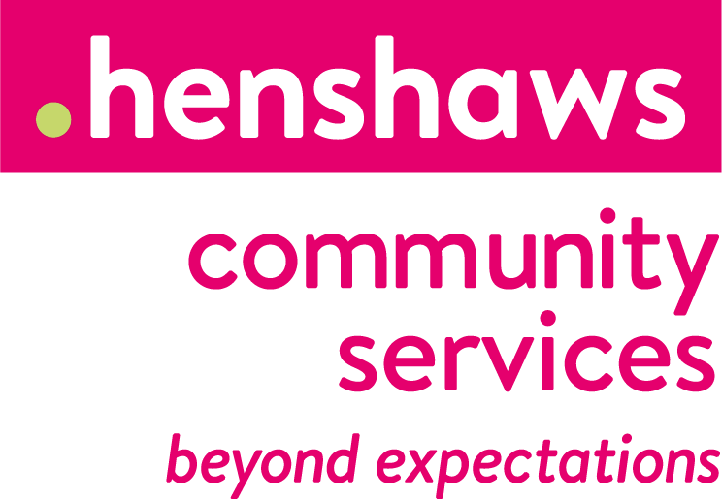

18th March 2020
Re: Henshaws response to Covid-19

Dear Parent/Carer

I am writing to you to let you know that Henshaws has made the decision in light of both government and Public Health England guidance to take preventative measures to reduce the spread of Coronavirus.

This includes a move to home working for staff and cancelling all activities and events for the time being. We will be moving towards more telephone-based support for the interim and our Children and Young People’s Enablement Officers remain very much available to families who may need information, advice or guidance. If there is anything we can do to support you remotely, please do get in touch and also update us with your email address and phone number if we don’t have it (contact details overleaf).

Please also be reassured that we are looking into ways to support children, young people and families in different ways during this time. You can keep up to date with news from Henshaws across our social media platforms:

Facebook: www.facebook.com/Henshaws
(closed group also ‘Henshaws Children & Families Manchester’)
Twitter: www.twitter.com/Henshaws
Instagram: www.instagram.com/henshaws_uk

You can also sign up to our Henshaws Knowledge Village, our online tool full of useful tips, tricks and information. Sign up to receive free e-newsletters and information at https://www.henshaws.org.uk/knowledge-village/

Stay safe and healthy and we hope to see you soon. Fiona & CYP Team

The Children and Young People’s team: Here to support you
Phone: 0300 222 5555
Generic email: cypactivities@henshaws.org.uk

Fiona Berry
Community Service Manager, Children & Young People
Email: fiona.berry@henshaws.org.uk
T: 0300 222 5555

Rachael Dickens
Oldham Enablement Officer Children & Young People
Email: rachael.dickens@henshaws.org.uk
M: 07970 638604

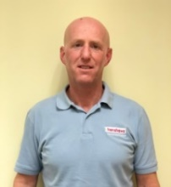
George Ferguson
Enablement Officer Children & Young People
Weekend Activities – Greater Manchester
Email: george.ferguson@henshaws.org.uk M: 07970 637 687

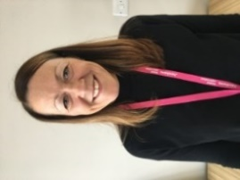
Carly Ferry
Enablement Officer Children & Young People (CYP)
Holiday Activities - Greater Manchester
Email: carly.ferry@henshaws.org.uk
M: 07970 637 391

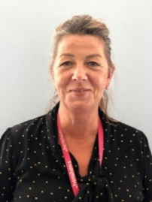
Marie Hansen
Enablement Officer Children & Young People (CYP)
Weekend Activities - Merseyside
Email: marie.hansen@henshaws.org.uk
M: 07970 637 019

Lydia Waker-Craig
Enablement Officer Children & Young People (CYP)
I Can Do It – Greater Manchester
Email: lydia.waker-craig@henshaws.org.uk
M: 07894 097 633

