Covid-19: Henshaws survey with blind and partially sighted people
A final report on survey findings, June 2020

“I am concerned that due to this pandemic some visually impaired people are isolated, and they may lose their hard-won independence.”

Authors: Helen Doyle, Evidence and Impact Analyst, Henshaws
Robert Cooper, Director, Henshaws

Contents
Page
Introduction from our Chair of Trustees 2
Context of survey 3
Findings of survey:
Key area of concern 1: Support from local sensory team/council 4
Key area of concern 2: Receiving public health messages 6
Key area of concern 3: Vulnerable category of service users 7
Key area of concern 4: Mental health and wellbeing 9
Key area of concern 5: Overall impact on our community 14
Understanding who is supporting our service users 18
In their own words 19
Conclusion 20
Appendices 22
References and contact details 24
Introduction from our Chair of Trustees
The Covid-19 coronavirus pandemic is the biggest health crisis for generations, and it is having a devastating impact on the lives of people across the world. The measures that the UK Government have taken to address the crisis, including restrictions on movement and social distancing, are absolutely necessary to save lives. However, the restrictions required by all of us since 23rd March 2020 have other consequences and implications, particularly so for people already facing challenges in their everyday lives through sight loss and possibly other health conditions and disabilities too.
That is why here at Henshaws, we realised this pandemic presented us with a unique challenge and we needed to establish its impact on our community so that we could track how best to support people and evidence the issues they are facing.
Our survey with 955 people, carried out from week 1 to week 11 of lockdown, has identified how the crisis affected people with sight loss in particular ways, and has highlighted the following key issues:
- The overwhelming majority of our respondents were not contacted by their local authority sensory team during the early stages of this pandemic.
- 41% of the people we spoke to did not receive any of the public health messaging about coronavirus/Covid-19 in a format which was accessible to them.
- One quarter of respondents were informed they were at very high risk from coronavirus (extremely vulnerable and should be shielding).
- There was considerable variation across Greater Manchester with regard to the support people with sight loss received during this time.
As a result of sharing our interim findings with our partners across Greater Manchester, and the wider visual impairment sector, we are pleased to be able to report that across Greater Manchester all ten Local Authorities have now agreed to send priority information out to the 11,000+ people who are registered blind or partially sighted in their areas.
This, coupled with our own intervention, has meant that communication has been made to 14,000+ people across our region.
As the impact of the pandemic and the restrictions on everyone’s lives continues, it is possible that more people with sight loss are going to struggle to cope. We will continue to use these findings and work with our partners across the health, social and third care sectors in the hope that we can come together to look out for those who are most at risk in our community, and ensure they are not marginalised at this unprecedented and difficult time.
Our findings raise some critical questions which we must address to ensure we are better prepared to respond to the needs of our community in the future.
Kevin Brady
Chair of Trustee Board, Henshaws

Context
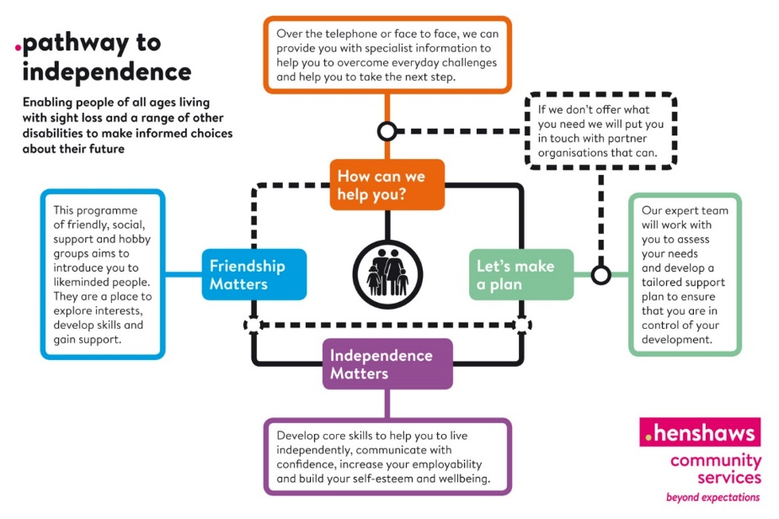
In more normal times, Henshaws Community Services enable people of all ages living with sight loss and a range of other disabilities to make informed choices about their future. We provide expert support, guidance and skills, helping people to fulfil their potential. Independence and friendship are at the heart of what we do to help people find the confidence to go beyond their expectations. Our operational delivery model is our award-winning Pathway to Independence (see Figure 1).

Figure 1. The Henshaws Pathway to Independence service delivery model.
Henshaws operates across Greater Manchester responding to the specific needs of the communities in which we work and partnering with key organisations across the locations to achieve better outcomes for people with sight loss (Cooper, Ridgway and Doyle 2015). Our Pathway to Independence remains our model for delivering services, albeit in a different way during the current times.
This report presents the results of the survey findings and is based on 955 responses. A large proportion of the people surveyed were in the 70+ age category as these were deemed our most vulnerable cohort of blind and partially sighted people and were contacted first as part of our Covid-19 response strategy. The majority of responses from the survey are also from across our key operating areas in Greater Manchester (Trafford, Manchester, Salford, Oldham, Tameside, Bolton and Stockport). This is where the focus of our outward bound calls has been, and so these are the 7 Local Authority areas focused on in the report - 94% of responses to the survey are from these areas, with 1% from the other GM areas (Wigan, Rochdale and Bury) and an additional 5% from the rest of the UK (the survey has been promoted via our online Knowledge Village, social media platforms, and with partner organisations working across the country). The demographic breakdown of our survey respondents can be found in Appendix 1.
Findings
This section of the report sets out the key findings from the survey, and how Henshaws have been responding to these findings over the last few extraordinary weeks. These findings have prompted a number of key questions, which are listed at Appendix 2 and included in some of our responses. We would encourage you to consider these as you read through and reflect on the report.
Key areas of concern: Concern 1 (support from local sensory team/council)
Our first concern at the outset of the pandemic was how this would particularly impact on our community who, as we know from our previous research and monitoring, are already dealing with a range of other issues alongside their sight loss. In our more recent user survey for example, we found that our visually impaired respondents also had the following conditions:
- 51% had high blood pressure
- 38% had physical disabilities
- 28% had diabetes
- 14% have had a stroke
We therefore needed to understand what other issues respondents were facing and what support and information they had been in receipt of, so we could understand their needs and co-ordinate our approach accordingly. We identified in the survey that 25% did fall within the very vulnerable category; this however was determined mainly by medical vulnerability and not social vulnerabilities.
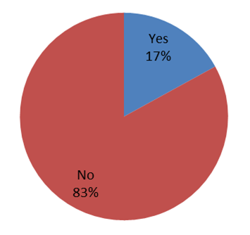
Respondents were asked therefore whether they had heard from their local sensory team, and Figure 2 shows that overall, only 17% had done. This figure has risen very slightly since our interim report was shared 4 weeks ago, when the percentage was 15%.

Figure 2. Has anyone from your local sensory team or council been in touch with you during this time?

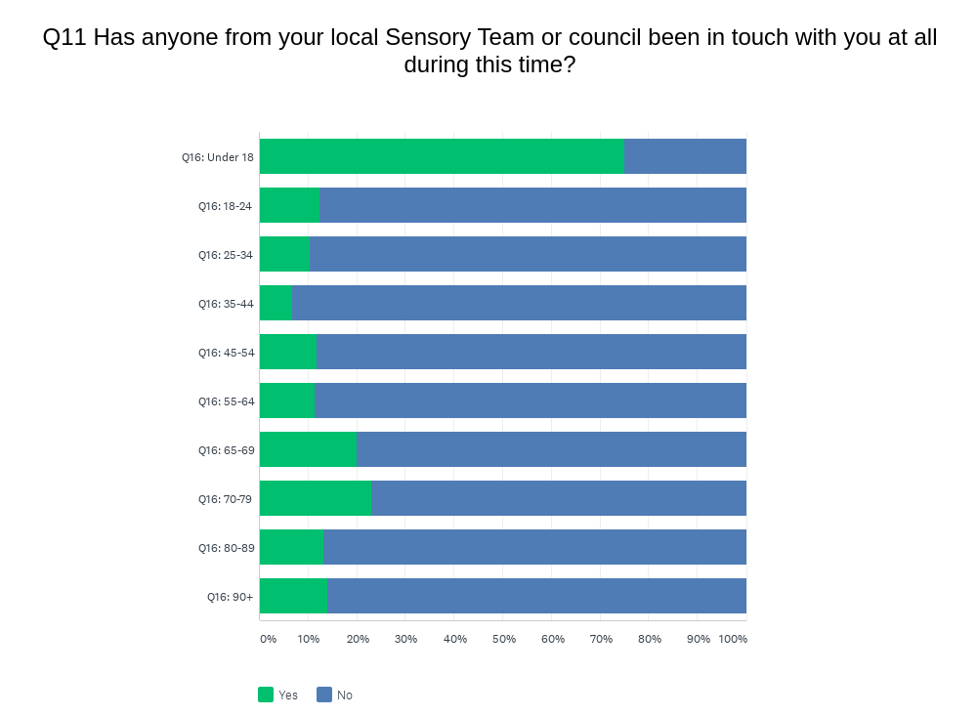
Figure 3 breaks this down further by age and shows that the majority (75%) of the under-18 age group have heard from their sensory team, with the other age groups showing no significant differences.

Figure 3. Has anyone from your local sensory team or council been in touch with you at all during this time?
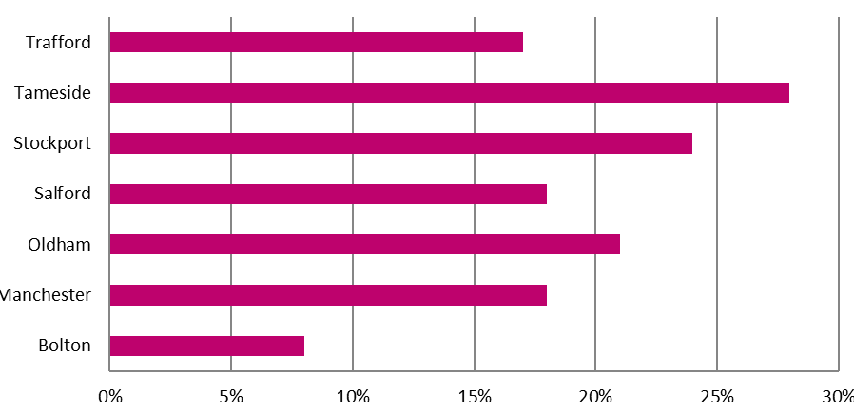
Analysis by location indicates that the highest level of contact was reported by Tameside respondents, where 28% of respondents had heard from their sensory team, compared to 8% of Bolton respondents who had heard from theirs. In our interim report, only 7% of Oldham respondents had heard from their sensory team and this has now risen to 21% showing that more people have heard as time has gone on in that area (see Figure 4).

Figure 4. Percentage of respondents who have heard from their local sensory team.
Our response to Concern 1 (support from local sensory team/council)
These findings underline one of our key questions - Why did it take some local authorities up to 11 weeks to communicate important messages to the registered population?
Finding that people were not hearing from their local sensory teams underlined the approach we had taken very early on – that we needed to proactively contact everyone we knew to find out how they were coping and what we could do to help.
Our information, advice and guidance service is available via our helpline number and email support. We also proactively called all the people we know and produced lists of all our service users (both adults and children) which were sorted by area, and then prioritised by age, whether they live alone, and have other medical conditions.
Our small team of call handlers pro-actively called our service users to assess their welfare needs and we implemented a red-amber-green (RAG) system to determine their vulnerability and inform our actions. We made over 4,000 calls to some of the most vulnerable people we know, and provided information, advice and guidance to them at this difficult and uncertain time.
We also teamed up with national partners, including RNIB and Visionary, who asked every local authority in the UK to write to people on their blind and partially sighted register, which they have a duty to hold. As a result, at the date of this report being published, all 10 Greater Manchester local authorities have agreed to communicate a letter to their register about the support they could receive. These are: Bolton (1,300), Oldham (600), Rochdale (500), Stockport (1,000), Tameside (1,000), Trafford (1,400), Wigan (1,600), Salford (1,800), Bury (800, via Bury Society for Blind and Partially Sighted People) and Manchester (have agreed in principle).
We have also continued to provide online support through our Knowledge Village resource, which has been able to respond quickly to get more information out to the people we support; new videos, blogs and eBooks have been added almost daily to our website and YouTube channel, offering hints, tips and tricks to help people with a visual impairment.
Key areas of concern: Concern 2 (receiving public health messages)
Another key concern we had at the outset was around whether any of the public health messages about protecting yourself against coronavirus had been received by respondents in a format which was accessible for them (e.g. large print). We already know that visually impaired people do not always receive key public health information in an accessible way. A study conducted by Henshaws for Manchester CCGs found 36% of visually impaired respondents felt they had little or no access to health information and that this was a major barrier (Henshaws, 2017).
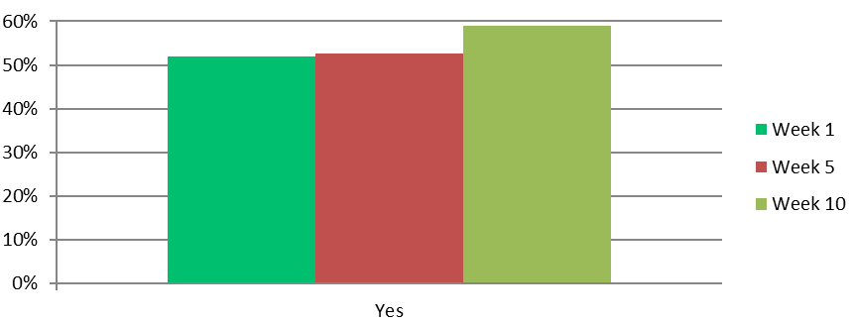
Responses to this question revealed an even split of 50/50 in our interim report (based on 5 weeks of results) of those who had received accessible information and those who had not. The final results show 59% of respondents state they have received public health messages accessibly which indicates this has improved as the weeks have gone on (see Figure 5). However, the issue still needs investigating further in terms of who is receiving it, from where and why is not everyone getting it in an accessible way?

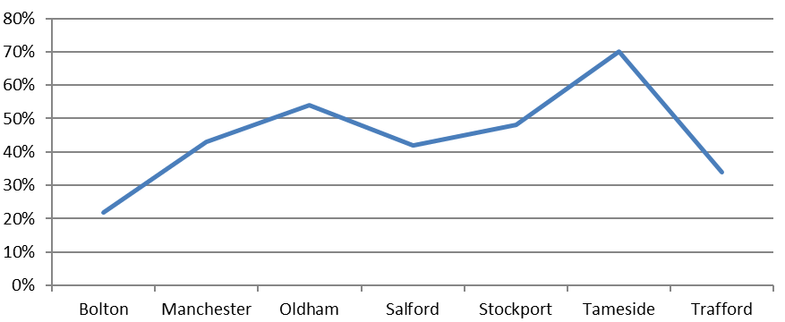
Figure 5. Have you received any of the public health messages about Coronavirus/Covid-19 in a format which is accessible to you?

Figure 6. Percentage of respondents who have not received public health messages in an accessible format, by location.
Analysis by location shows that Tameside has the highest overall proportion of respondents who have not received public health messages accessibly (see Figure 6).
The results by age back this up with variation seen across the age groups; under 18’s and over 90-year olds reporting the highest levels at 75% and 61% respectively (see Figure 7).
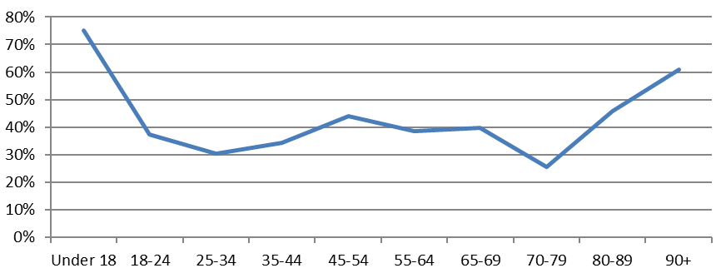

Figure 7. Percentage of respondents by age group who have not received public health messages about coronavirus/Covid-19 in a format which is accessible.

Our response to Concern 2 (receiving public health messages)
Our key question - Why did Public Health England, NHS England, local health organisations and Directors of Public Health fail to harness the Register of Blind and Partially Sighted people to ensure the key health messages were communicated appropriately to this community?
The fact that there is such variation across seven of the Greater Manchester local authority areas clearly needs further investigation and highlights the need for a centralised resource for visual impairment across Greater Manchester to ensure equity of provision and improve outcomes for all.

Key areas of concern: Concern 3 (vulnerable category of service users)
Our next key concern was around people who we knew would be more vulnerable due to other health conditions and disabilities, so we needed to try and ascertain how many people had been informed they fell into the ‘extremely vulnerable to coronavirus’ category and therefore needed to shield themselves.
Figure 8 shows that a quarter of respondents have been informed that they fall into this category, indicating the level of need among this group who are managing other complex health conditions alongside their visual impairment.

Figure 8. Have you been informed that you fall into the extremely vulnerable category of people with specific medical conditions?
Analysis by location (see figure 9) indicates Tameside and Bolton have the highest percentage of respondents who fall into this category, and again this will help us plan our service delivery moving forward so that we can target resources where they are needed most across Greater Manchester, and work with key partners in those areas to offer the most appropriate provision.
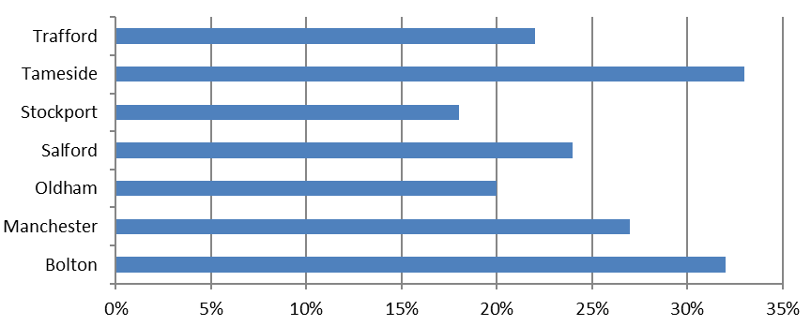

Figure 9. Percentage of extremely vulnerable respondents with specific medical conditions, by location.
Analysis by age presents a mixed picture (see Figure 10) – we might have expected that the older respondents were the more likely to fall into this category. However, it is the 35-44 year old group who report the highest level, at 38.2%.

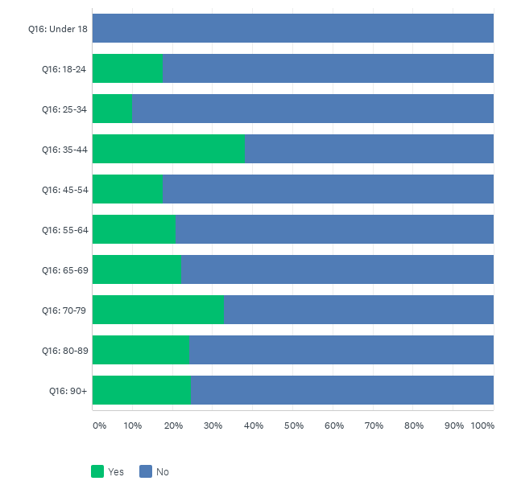

Figure 10. Have you been informed that you fall into the extremely vulnerable category of people with specific medical conditions? (by age)

Our response to Concern 3 (vulnerable category of service users)
Our key question - Why were blind and partially sighted people not included on the government’s extremely vulnerable list and provided with the appropriate levels of support?
Anecdotally we are hearing from some of the calls our team are making that people are receiving the letters in standard format. Therefore, some people don’t know whether they have had it because they live alone and can’t manage their post currently, or they may know they have had it but can’t actually read it. The letter is a passport to many of the services now available such as food schemes, etc. and if people can’t access the letter, they will be unable to access the support.
This is something that we will continue to monitor and track, but again highlights that a central resource to manage crucial information such as this in the right format is hugely important to ensure visually impaired people are not excluded from key information provision.

Key areas of concern: Concern 4 (mental health and wellbeing)
We know from much previous research and service delivery that there is considerable evidence to show that people with sight loss are at greater risk of mental health issues, isolation, and loneliness.
Due to the very nature of the measures needed to be put in place to control the pandemic, another of our major concerns upon the announcement of the lockdown measures was how this would affect our community in particular, and whether it would exacerbate some of the problems and issues they were already dealing with.
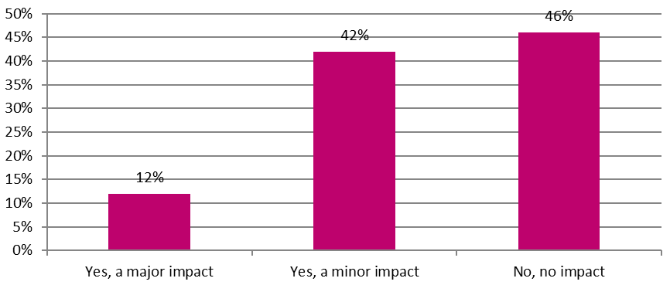
Respondents were asked how the pandemic had affected their mental health (see Figure 11) – overall 54% of respondents stated it had had a negative impact (12% of these felt this was a major impact). This is higher than the general population where 47% reported that their mental wellbeing was affected (ONS, 29/5/2020).

Figure 11. Do you feel that worry or stress related to the coronavirus has had a negative impact on your mental health or not?
Figure 12 indicates high levels of respondents reporting a major impact on their mental health in week 1, which then fell away in week 2 but started to climb following that, before briefly falling and then reaching a peak in week 8; possibly indicating the longer that peoples’ lives were being affected, the harder it may have been impacting on their mental health and resilience.
We can then see a fall in week 9 (although it has climbed again slightly in week 10) – this may be a result of the rules around lockdown changing somewhat. As we move into our new way of delivering services, it will be important to monitor this and ensure the mental health of the people we support is considered throughout our new model of delivery.
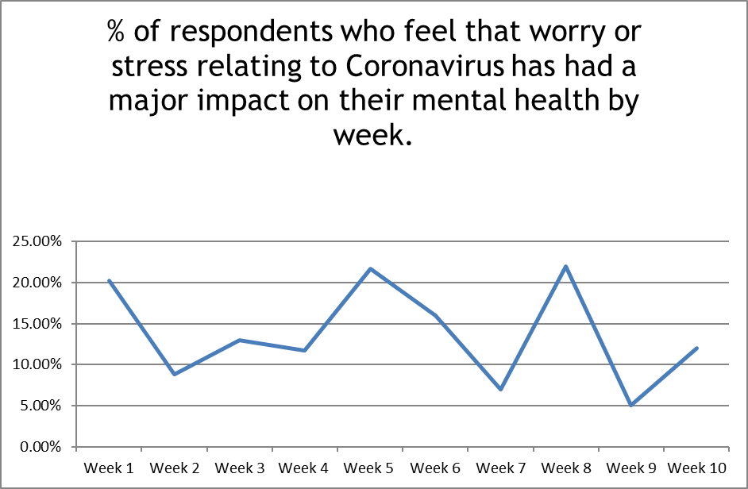

Figure 12. Percentage of respondents who feel that worry or stress relating to coronavirus has had a major impact on their mental health, by week.
The analysis by location in Figure 13 shows that Tameside, Oldham and Stockport respondents seem to be particularly affected with regard to the impact on their mental health, and it will be important to bear this in mind when delivering support into these areas over the coming weeks and months.

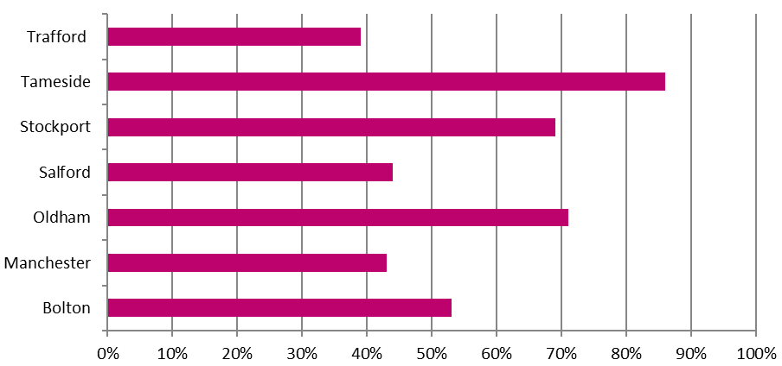

Figure 13. Impact on mental health, by location.

Figure 14 highlights the response to this question by gender, where we can see that women are slightly more likely to report an impact on their mental health.

Figure 14. Do you feel that worry or stress related to coronavirus has had a negative impact on your mental health or not?

Analysis by age also indicates that overall, the younger age groups report more impact on their mental health than older age groups, with the exception of the over 90s where the negative impact is slightly higher (see figure 15). This will be critical for us to understand for the planning of future services.
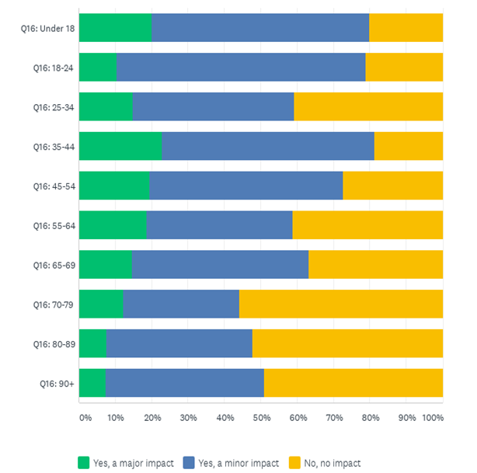

Figure 15. Do you feel that worry or stress related to coronavirus has had a negative impact on your mental health or not?
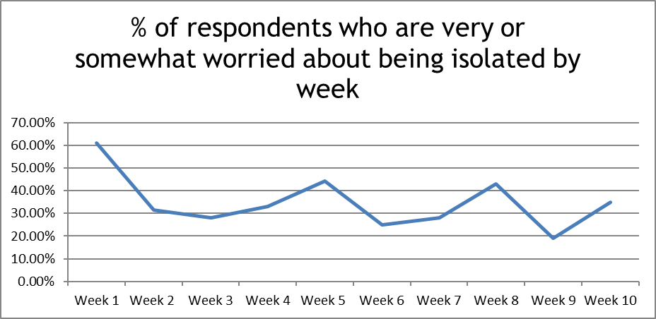
Levels of isolation are clearly related to peoples’ resilience and mental wellbeing, so we wanted to understand this issue in a bit more depth. Figure 16 indicates that there were high levels of concern about being isolated at home in week 1, which fell during week 2, and has fallen some weeks since then but now appears to be rising again in the final week of the survey; highlighting that the length of the lockdown may have impacted on how worried people are about being isolated.

Figure 16. Percentage of respondents who are very or somewhat worried about being isolated, by week.
Analysis by location indicates that again Tameside respondents are most concerned about levels of isolation, which corresponds to their reporting of a negative impact on their mental health (see figure 17).

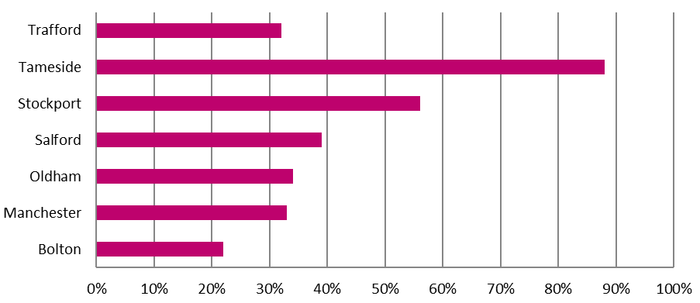

Figure 17. Percentage of respondents who are worried about being isolated at home, by location.
Analysis by age, which can be seen in Figure 18, shows that the older people are the less likely they report being worried about being isolated at home, with the age group reporting the most concern being under-18s.
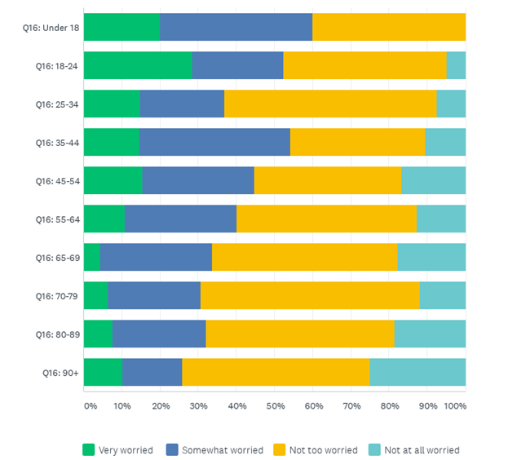

Figure 18. How worried, if at all, are you about being isolated at home?

Our response to concern 4 (mental health and wellbeing)
To reduce the potential level of isolation experienced, we established that some people would benefit from a telephone befriending service; so we have staff and volunteers calling these people regularly for a chat and a catch up, providing a friendly and listening ear for those who most need it.
Our Children and Young Peoples’ team have also been hosting online catch ups for the children and families they work with, so they can socialise and chat and keep in contact with each other even though they are not able to physically meet up.
We quickly adapted our digital assessment service where our expert team train people in the use of various assistive technologies that helps to increase knowledge, skills and independence, and crucially to reduce social isolation. Our Digital Team is carrying out remote training over the telephone, using remote access technology, and video conferencing tools enabling people to still receive the training they require and keep in touch with their family and friends.
We also have a counsellor on our staff team who has moved to providing telephone support and sessions, and we can refer people on if we feel they need more in-depth support during this time.
In week 3 of our Covid-19 response, and due to the early data analysis of our survey findings, it was clear that there was a growing pattern emerging of concerns with mental health and wellbeing of staff, volunteers and service users. As a result, all staff and volunteers undertook additional mental health training and have been certified Mental Health Champions (certified by Champion Health).
Transport – due to many regular transport services being affected during this time we are also aware that this is affecting visually impaired peoples’ ability to access medical appointments and essential shopping in the same way as they have done previously, with a negative impact on their independence and levels of isolation. We are working closely with a number of agencies across Greater Manchester to alleviate the effects of this, in particular in relation to the period of time patient transport services to Manchester Royal Eye Hospital were halted to support people to get to their critical appointments. This will continue to be reviewed.

Key areas of concern: Concern 5 (overall impact of the pandemic on our community)
Obviously every person in the UK has been affected and disrupted by the coronavirus pandemic. However, it is true to say: “We are all in the same storm, but we are not all in the same boat.”
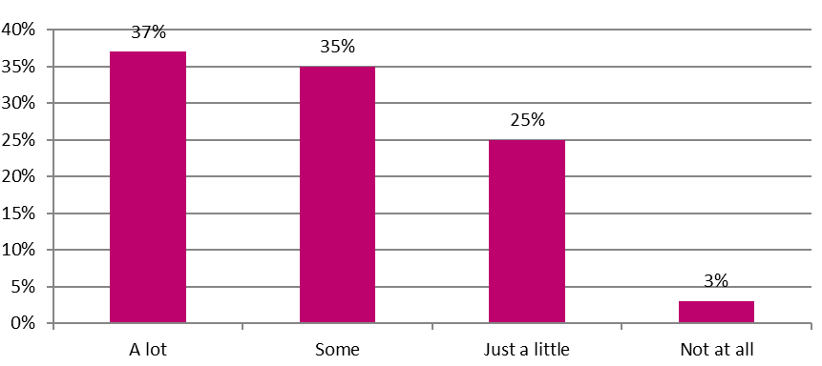
Although many of us may be experiencing the same types of concerns and levels of disruption, it is crucial to understand how our respondents are being affected specifically so we are able to respond accordingly.

Figure 19. How much, if at all, has your life been disrupted by the coronavirus outbreak?
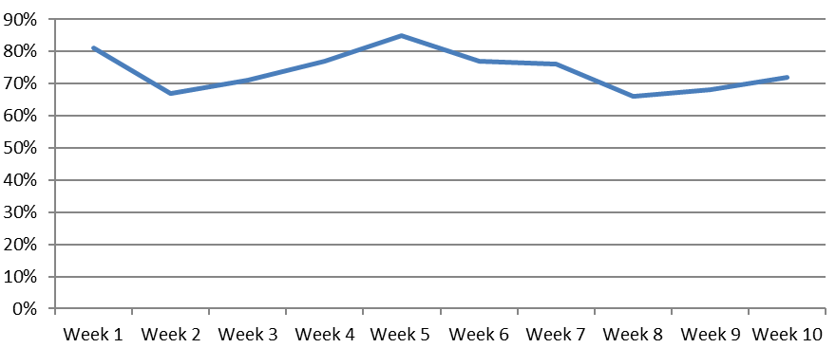
Figure 19 highlights that 72% of respondents have so far reported that their lives have been disrupted a lot or somewhat since the start of the outbreak, and we can see how this has changed over the weeks in Figure 20.

Figure 20. Respondents who report their life has been disrupted a lot or somewhat over the weeks.
This analysis highlights that in week 5 of the lockdown period there was a peak in how disruptive respondents felt the pandemic had been, with then a slight fall in week 8, but levelling out at 72% by week 10.
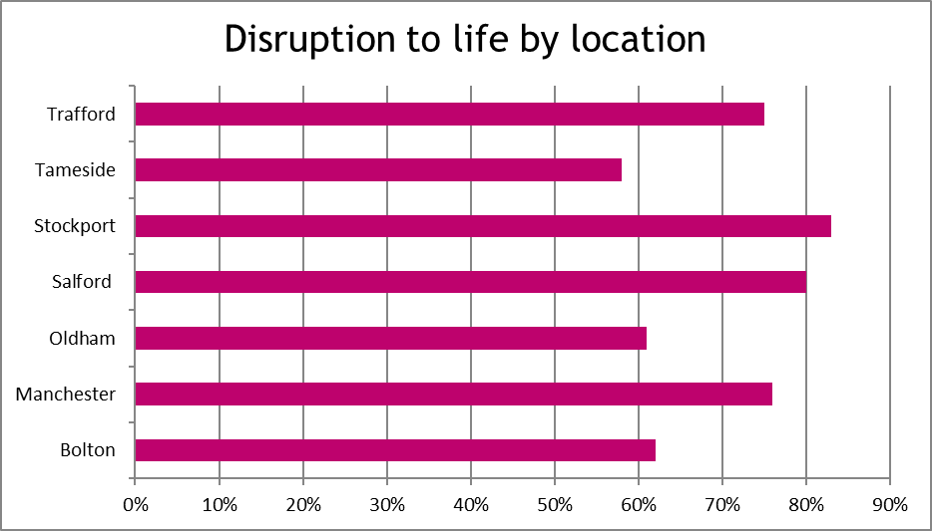
Analysis of Greater Manchester respondents highlights those areas where people seem to be affected most. Figure 21 indicates that Stockport respondents report greater levels of disruption than other areas and this provides us and key partners with important information regarding where we need to target support and provision.

Figure 21. Disruption to life, by location.
Figure 22 clearly shows that younger respondents were more likely to report higher levels of disruption due to the pandemic, with 25-34 year olds reporting the most significant disruption and over 90 year olds reporting the least. It is also important to point out that under-18s are the only group reporting that the pandemic has had little or no disruption on their lives.
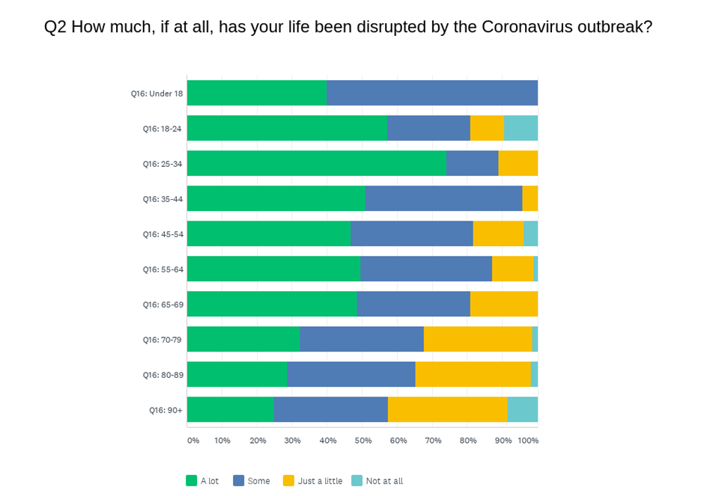

Figure 22. How much, if at all, has your life been disrupted by the coronavirus outbreak?
The survey asked people about 5 key areas they may have concerns about during this time, and the results overall can be seen in Figure 23.
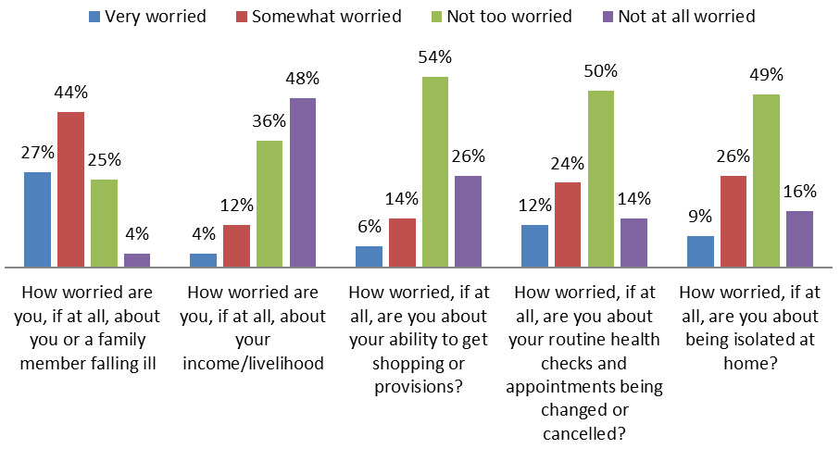

Figure 23. How worried are respondents about aspects of the lockdown?
Overall respondents are most worried about themselves or a family member becoming ill (71% worried) and are least worried about their income or livelihood (84% not worried). However, this is affected somewhat by age where we can see that the working age respondents do show greater levels of worry about their income or livelihood being affected (Figure 24).

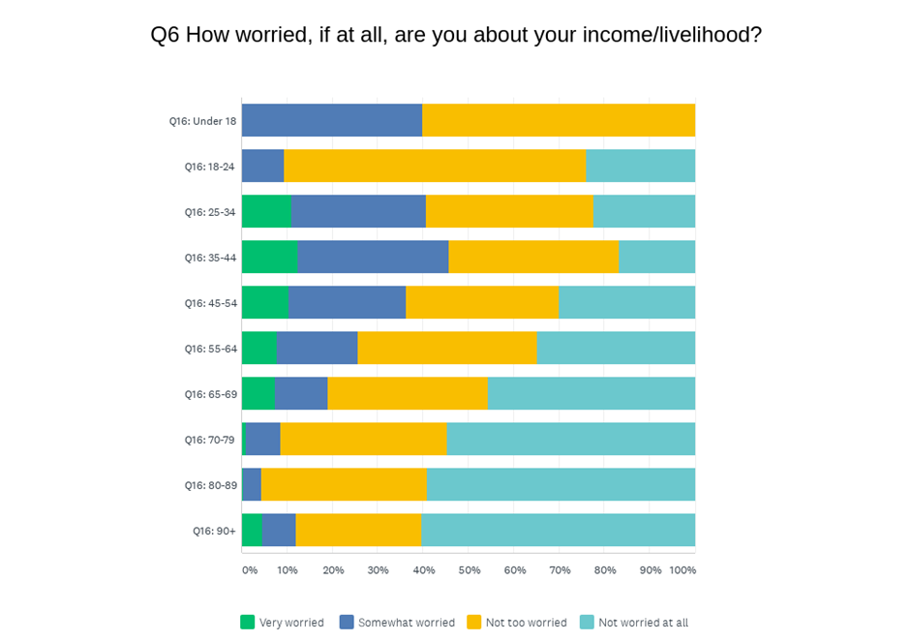

Figure 24. How worried, if at all, are you about your income/livelihood?
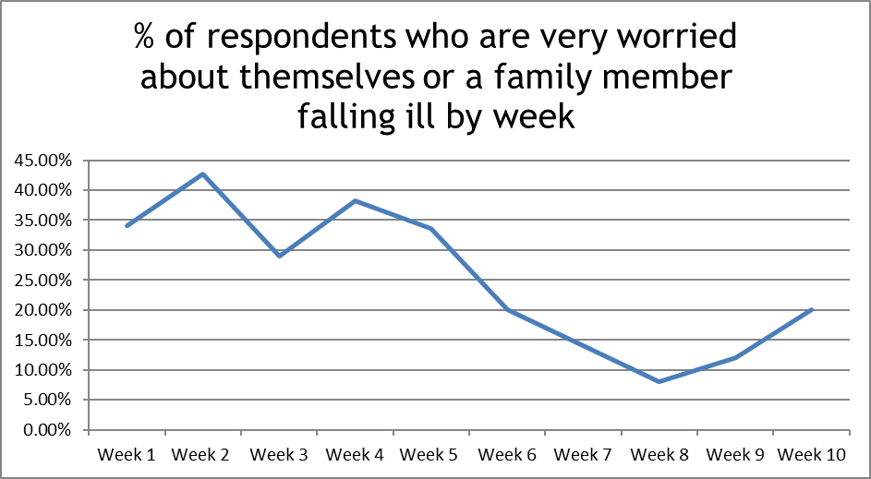
Weekly analysis (Figure 25) shows that the levels of worry around themselves or family members falling ill peaked in week 2 of the lockdown, which is unsurprising considering this was the time when media coverage about the levels of infection and rising death rates were very intense. This continued to fall but has risen again slightly in weeks 9 and 10, perhaps as lockdown measures are eased and fears about contracting the virus come to the fore again.

Figure 25. Percentage of respondents who are very worried about themselves of a family member falling ill, by week.

Our response to Concern 5 (overall impact of the pandemic on our community)
Once we realised the impact of the pandemic on our community through our interim findings we reported them to our national partners, and this was one of the main reasons we wanted local authorities to communicate to their blind and partially sighted registers. It was identified as one way we could reach out to those people not known by Henshaws and its partner charities, and ensure they received the appropriate support.
Our staff team have developed an extensive mapping resource which details the support available to communities across Greater Manchester during this time. We found that in the first couple of weeks of the lockdown people were particularly concerned about being able to get their shopping and medical supplies, and we were able to network them in with local agencies and providers who could support them. We also produced online resources to support people, such as our blog ‘12 top tips for shopping for someone with a visual impairment.’
What will be the lasting impact to the blind and partially sighted community in the post-Covid years? What support will be in place to mitigate the risks of these longer-term impacts?

Understanding who is supporting our service users
Understanding the levels of support people have around them was also important to analyse, and 98% of respondents have reported that they have people around that can support them, which is encouraging. Of these however only 39% are supported by family who they live with, and Figure 26 shows the breakdown of support in more detail.
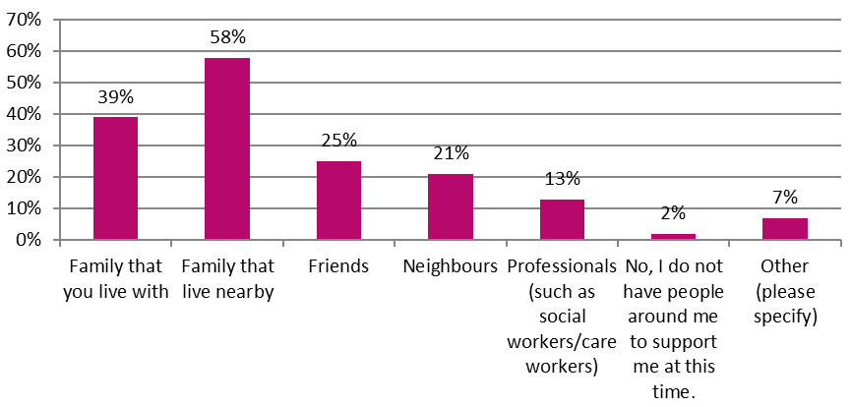

Figure 26. Who are the people who are able to support you?
(NB. totals do not add up to 100 as respondents were able to select more than one option.)
Why were so many blind and partially sighted people reliant on family, friends and neighbours to receive the vital support and supplies required to help them during the initial lockdown phase?
Over the weeks we have seen that the number of people selecting ‘other’ (for who they have around them to support them) has risen. The following responses are typical of what people are saying:
“I did not have people to support me at the beginning - I now have help from Tameside council and a neighbour has offered support.”
“A local charity now does some shopping.”

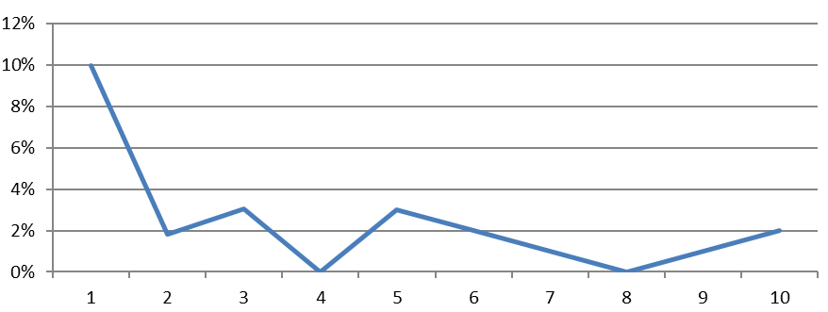

Figure 27. Weekly analysis of people with no-one to support them.
Figure 27 also shows that the general trend over the weeks for respondents who have no-one around to support them has fallen considerably over the 10 weeks to just 2% of respondents, who at week 10 reported they had no support.

In their own words
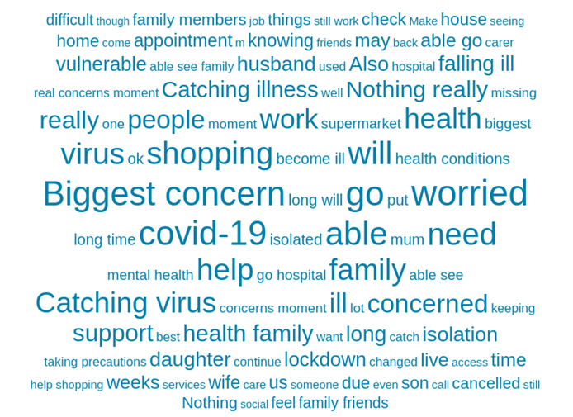
Finally, we asked people what their biggest concern was at this time and what might help them; the word cloud (Figure 28) indicates, by level of frequency of the words and phrases people have used, the main issues which are emerging for respondents (the larger the words the more frequently they have been used).

Figure 28. Can you please tell us what your biggest concern is at this time and what might help you?
These responses in full are typical of what respondents have said:
“My biggest concern is will I have the confidence to go out after lockdown?”
“I am concerned about catching the virus. I have additional health needs, so I am very vulnerable. I am being very careful though and following the guidelines.”
“My biggest concern is having to cancel an eye hospital appointment – my sight has deteriorated, and I was referred from the opticians, but it didn’t feel safe at the time.”
“My biggest concern is that my medical appointments may be cancelled.”
“I have had 2 eye appointments cancelled, so I was worried about that; but someone called me last week and booked me in for an appointment this week, so I am happier now.”
“I am worried about my sight deteriorating further.”
“Not being able to get medication when needed.”
“I am worried about catching the virus. It was about getting food, but I now have priority order slot, government food box and council number in case needed.”
“I am very worried about my husband as he is in the high-risk category and cannot go out for 12 weeks - I’m feeling very claustrophobic and it is putting a strain on the marriage.”
“My main concern is time spent indoors - effect on mental health.”
“I am a very sociable person, so I am missing getting out and meeting people now.”
“Mental health being impacted or having no peer support at the minute.”

Recommendations for Henshaws support have included:
“Maintaining sanity videos from Henshaws would help!”
“Developing links with groups would help.”
“A befriending service.”

Conclusion
These findings will be used by Henshaws to plan for our next phase of delivering services in the coming months, when restrictions and social distancing are likely to remain in place and restrict our normal model of service delivery.
We all accept the ramifications of this pandemic are likely to be felt for a long time to come, and it is worth bearing in mind that the fallout from the cessation of eye health services is likely to have a hugely significant impact. A BBC article, based on an as yet unpublished survey from the UK Ophthalmology Alliance and the Royal College of Ophthalmologists, suggests that at least 10,000 people are at risk of suffering irreversible damage to their sight because of missed care during lockdown (bbc.co.uk 10 June 2020).
The figures in our area of Greater Manchester are also of concern:
- Over the last 10 weeks in Greater Manchester there may have already been in the region of 127,280 eye tests cancelled.
- There may have been up to 72,920 eye clinic outpatient appointments cancelled.
- There would under normal circumstances have been 667 people newly registered across the North West in a 10-week period – what has happened to these people during this time? (based on figures from RNIB Sight Loss Data Tool v4.2)
As a sight loss charity, we need to prepare ourselves for what the next few months will bring, and how we can support people and services through the fallout of the pandemic. These findings will therefore be shared with key partners so they can also inform their responses and future planning.
Will sight loss charities finally be fully recognised and integrated across the Adult Health and Social Care sight loss pathway?
Appendix 1
Demographics – who has responded to our survey?
71% of respondents are visually impaired themselves, and 29% have completed the survey on behalf of a visually impaired person.

Figure A. Survey respondents, by gender Figure B. Survey respondents, by age
Figures A and B highlight the gender and age breakdown of respondents showing that 61% are female and 63% are aged 70 and over (our respondents were generally older due to our RAG process which highlighted the need to contact those aged 70+ as a priority).
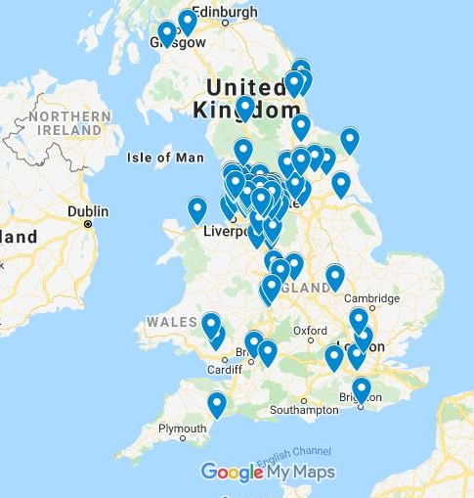
The heat map (Figure C) shows where respondents are located – although predominantly responses have been from across Greater Manchester, because of the reach of our online provision, Knowledge Village, and the fact we have shared the survey with key partners, this has meant we have had responses from across the UK.
Figure C. Heat map to show location of survey respondents across the UK.

Appendix 2
Key questions for consideration
1. Why did Public Health England, NHS England, local health organisations and Directors of Public Health fail to harness the Register of Blind and Partially Sighted people to ensure the key health messages were communicated appropriately to this community?
2. Why did it take some local authorities up to 11 weeks to communicate important messages to the registered population?
3. Why were blind and partially sighted people not included on the government’s extremely vulnerable list and provided with the appropriate levels of support?
4. Why were so many blind and partially sighted people, who were classed as extremely vulnerable due to other health conditions, not communicated to in the appropriate accessible format?
5. Why were so many blind and partially sighted people reliant on family, friends and neighbours to receive the vital support and supplies required to help them during the initial lockdown phase?
6. What will be the lasting impact to the blind and partially sighted community in the post-Covid years? What support will be in place to mitigate the risks of these longer-term impacts?
7. Were blind and partially sighted people marginalised by authorities? Were they the forgotten community?
8. Will sight loss charities finally be fully recognised and integrated across the Adult Health and Social Care sight loss pathway?

References
BBC News, (10 June 2020) Coronavirus: Eyesight of thousands at risk due to missed care, www.bbc.co.uk/news/health-52968845
Cooper,R, Ridgway,A, Doyle, H (2015) Henshaws Pathway to Independence: A new model of service delivery for people with visual impairment: International Journal of Ophthalmic Practice, Vol 6, No 1 Feb/March 2015, pp30-35.
Doyle, H (2017) Understanding the health needs and well-being of people living with sight loss in Manchester, Henshaws and North, Central and South Manchester CCGs
Office for National Statistics (29 May 2020) Coronavirus and the social impacts on Great Britain
RNIB Sight Loss Data Tool v4.2, 2019

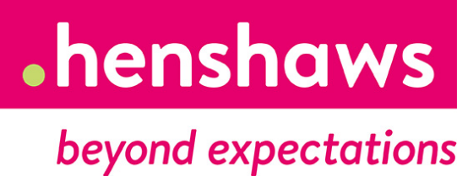

Please contact us If you require this document in an alternate format.
For further information or to provide feedback on the findings, please contact:
0300 222 5555 or email helen.doyle@henshaws.org.uk
Henshaws
4a Washbrook House, Lancastrian Office Centre
Talbot Road, Stretford, Manchester M32 0FP
Registered charity no. 221888

