For Office Use Only:
Art Maker Name:
Date Received:


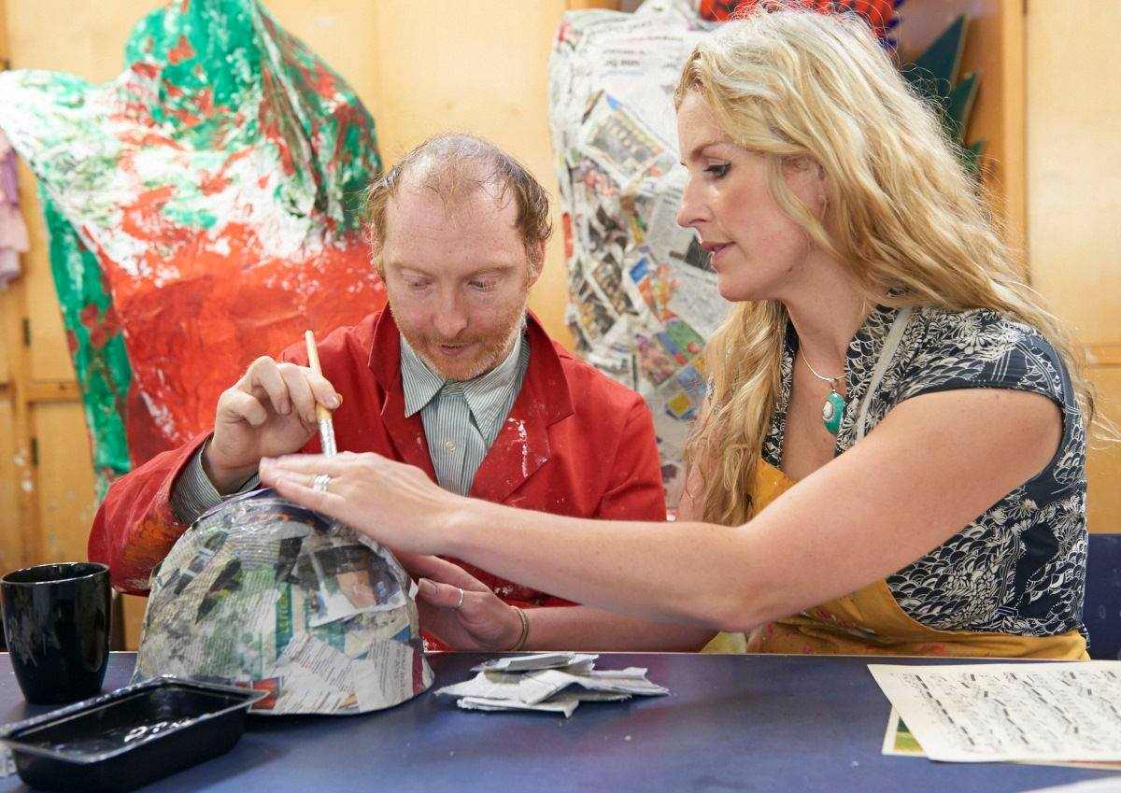

. Application form

.Personal details

Section 1
First name(s): |  | Surname:
Date of birth: | Gender: Male Female Transgender
Address:

Postcode:

Parent/carer name(s): Mr/Dr/Mrs/Miss/Ms

Same as Art Maker

Address:

Postcode:

E-mail addresse(s):

Telephone no’s (home): |  | Telephone no’s (mobile):
Local Authority:

Do you have an EHCP? Yes No If yes, please enclosed a copy (draft, amended or final).

How did you first hear about Henshaws Arts & Crafts Centre?

.Contacts

Section 2
GP:  Address:  Telephone no: | Social Worker:  Address:  Telephone no:
Education, Health, Care, Plan Co-ordinator:

Name and address:

Telephone no:

Please give details of other professionals who work with you, such as therapists, psychologists, respite services/carers, community nurse, medical consultants etc. Continue on a separate sheet if necessary.
Role:  Name and address:  Telephone no: | Role:  Name and address:  Telephone no:
Role:  Name and address:  Telephone no: | Role:  Name and address:  Telephone no:

. Ethnic Origin and Religion

Section 3
First language: | Do you speak English? Yes No
What is your ethnic group?

Prefer not to answer

White:
Welsh/English/Scottish/Northern Irish/British Irish
Gypsy or Irish Traveller Any other white background.
Please Describe:
Mixed/Multiple ethnic groups:
White and Black Caribbean White and Black African
White and Asian Any other mixed/multiple background.
Please Describe:
Asian/Asian British:
Indian Pakistani
Bangladeshi Chinese
Any other Asian background
Please Describe:
Black/African/Caribbean/Black British:
African Caribbean
Any other Black/African/Caribbean background.
Please Describe:

Other ethnic group:
Arab Any other ethnic group.
Please Describe

What is your religion?

Do you have any religious observance requirements?  If yes, please give details: (e.g. opportunities for prayer, fasting, etc.). |  | Yes No
Do you have any religious or cultural dietary requirements?  If yes, please give details |  | Yes No
Do you wear specific clothing due to your religion or culture?  If yes, please give details |  | Yes No
Any additional information relating to your religion or culture.

. Learning Difficulty, Disability and/or Condition

Section 4 please tick all that apply.
Acquired brain injury
ADHD
Anxiety
Asthma
Autism
Cerebral palsy
Developmental delay
Diabetes
Down syndrome
Dyscalculia
Dysphagia
Dyspraxia
Dyslexia
Emotional behavioural difficulties
Epilepsy
Eating and drinking difficulties
Essential wheelchair user
Heart Condition
Wheelchair user (Long Distance)
Fragile X syndrome
Genetic condition
Name of condition:

Hearing Impairment
Impairment affecting mobility
Neurological condition
Mental health condition:
Name of condition:

Moderate learning difficulty
Multiple/profound impairment
Scoliosis
Severe learning difficulty
Speech/language/communication difficulty
Temporary impairment
Name of condition:

Visual impairment
Do you receive any therapies? Yes No

Speech therapy Occupational therapy Physiotherapy Hydrotherapy
If yes, please give details: (when, how long, where, etc.)?

. Medical Condition

Section 5 Diagnosis
Please bring all medical support equipment to your assessment.

Please tell us about your diagnosis/diagnosis:

How does your medical condition affect your everyday life?

Section 6 Health and Care Protocols
Please enclose all current care plans and/or protocols related to the care of the Art Maker that Henshaws staff will need to follow.. These must have been written and signed by medical professional. Failure to provide plans and protocols will result in Art Makers not being able to attend the Arts & Crafts Centre until such plans and protocols have been provided for safety reasons.

Health and care protocols:

Epilepsy Management Plan N/A Yes Enclosed

Stoma Care Plan N/A Yes Enclosed

Suction Care Plan N/A Yes Enclosed

Gastrostomy Care Plan N/A Yes Enclosed

PEG Feeding Protocol N/A Yes Enclosed

Eating and Drinking/feeding Plan (Swallow/choking risks) N/A Yes Enclosed

Any other information, plans or protocols we to be aware of:

Section 7 Medications and Homely Remedies
Do you any Medication prescribed: Yes No

Are any of these control drugs? (Please indicate which ones) Yes No

If yes, please give details below and provide us with a copy of all prescriptions that will be administered by Arts & Crafts Centre staff.

Medication | Reason for Medication | Dosage and Frequency | Date it was last reviewed
Homely Remedies
Clinical need | Medicine to be used | Dosage and Frequency | GP approval
Do you have a shunt in situ?  If yes, what advice have you been given about this? |  |  |  |  | Yes No
Section 8 Pain
Do you suffer from any pain / discomfort?  If yes, where is the pain / discomfort and how often do you experience it? |  |  |  |  | Yes No
How do you express that you are feeling pain / discomfort?

What do we need to do to help with the pain / discomfort?

Do you have any allergies?  If yes, please give details of these and the treatment you require: |  |  |  |  | Yes No
Section 9 Behavioural Concerns
Do you require any support in relation to your behaviour?  If yes, please give details of any support in place (including Behaviour Support Plans and functional assessments/reports) |  |  |  |  | Yes No
Have you had any input from a professional in relation to your behaviour?  If yes, please give details including name and address: |  |  |  |  | Yes No
Do you have a Positive Behaviour plan? (If yes, please enclose a copy) Yes No

If yes have you enclosed with this application form? Yes No

Can you tolerate?

Large groups Crowded places Noisy places
Noisy people People being near you
Participating as a group member

Please give details:

Do you have awareness of others? |  |  |  |  | Yes No
Do any of the following apply to you?

Antisocial behaviour Inappropriate interpersonal / sexual behaviour
Self-injurious behaviour Self-Harm
Regularly seeking attention Over activity
Aggressiveness Obsessive behaviour/fetish
Phobias/fears N/A

Please give details:

How do you behave if you are upset? (e.g. angry/anxious/worried)

Shouting Screaming Crying Hitting others
Swearing Self-injurious Self-harm Biting yourself
Biting others Talking fast Throwing objects Threatening others Hyperactive Running away Being quiet Withdrawn
Hitting yourself Other N/A

Please give details:

What triggers could affect your behaviour?
Please give details: (e.g. changes to routine, loud noise.)

Where do you get upset?
Home Community Respite Other

How often do you get upset?

More than once a day Daily Weekly Fortnightly
Monthly Three monthly Six monthly Yearly Never

How long does it take for you to feel better?
10 minutes 20 minutes 30 minutes 1 Hour
A couple of hours Several hours All day Few days

Please give details:

Have you ever had input and support from your local CAMHS Team  (Child and Adolescent Mental Health Services) or Adult Mental Health Team?  If yes, please give details and send in you latest report: |  |  |  | Yes No
Section 10 Sensory Integration - please complete the tick boxes below
Age of walking if applicable

Has the Art Maker had a sensory assessment? (If yes, please enclosed a copy) Yes No

Section 11 Epilepsy
If no to epilepsy, please skip and go to section 12
Do you have any form of epilepsy?  If yes, what type of seizures do you have (e.g. absences, grand-mal, tonic-clonic). |  |  |  | Yes No
Do you have any warning signs prior to a seizure?  If yes, please describe them: |  |  |  | Yes No
Are you prescribed any emergency medication for seizures?  If yes, what is it? |  |  |  | Yes No
When was your last epileptic seizure?

Are there any other medical or care needs not mentioned elsewhere or not currently being treated but which we may need to be made aware of?

.Physical Needs
Section 12 Walking
Please bring all communication support equipment to your assessment, including: wheelchairs, walkers, splints etc.

Can you walk?

Independently With support I use a wheelchair for long distances
I am an essential wheelchair user

Do you use any of the following walking aids?

Splints Orthotics Other walking aids

Please give details, including who provided these for you:

Do you use stairs independently? |  | Yes No
Section 13 Balance
Can you walk around confidently and independently? If no, are you able to move yourself around on the floor (e.g. crawl, roll)? |  | Yes No
Do you need assistance with walking e.g. due to poor balance?  If yes, what assistance do you require? |  | Yes No
Do you need assistance to stand or sit down?  If yes, what assistance do you require? |  | Yes No
Section 14 Hands
Can you use both of your arms? |  | Yes No
Do you have a dominant hand? |  | Yes No  Left  Right
Can you use your arms/hands to do the following?

Reach objects Grasp objects Release objects
Use scissors Open a door independently

Section 15 – Wheelchair User
If no, please skip and go to Section 16
Are you an essential wheelchair user?  Manual chair Power chair  Please give details: (e.g. make and model, who provides your wheelchair). |  | Yes No
How long have you had your wheelchair?

Have you had training in driving / propelling your wheelchair? If yes, from who and when? |  | Yes No
Do you drive your wheelchair?
Independently(electric) Self-propel With assistance

Do you use your wheelchair independently outdoors?  If yes, please give an approximate distance you are able to travel: |  | Yes No
Do you use any additional specialist seating in your wheelchair(s)? If yes, please give details: |  | Yes No
Do you transfer?

Independently With some support Using a hoist with support
With a patient turner Other
If you use a hoist and sling to assist with transfers, please give details of the sling you use:

Do you need to spend time out of your wheelchair during the day?  If yes, please give details (e.g. lying on the floor, on a wedge, etc.): |  | Yes No
Section 16 Equipment and Resources
If none, please skip and go to Section 17
It is important that we are aware of all equipment that you currently use e.g. hoists, toilet / shower chair, eating and drinking equipment, wheelchair, low vision aids, communication aids, etc.

Please can you list all equipment that is used to assist you and identify where this equipment is from / funded by, e.g. NHS, Social Services, and private ownership.

If you are invited to assessment it is vital that all essential equipment that you use on a day-to-day basis is available during the assessment visit; this will allow us to gain a clear picture of your abilities and make your stay more comfortable.

Equipment currently used | Provided/funded by |  | Please tick if bringing to assessment
Please give us any other information your think we should be aware of regarding equipment:

Section 17 Social and Leisure Activities
What makes you happy?

What sort of social/leisure activities do you like to do?

Do you like swimming? | Yes No
Section 18 Access to the Community
Are you happy to go out in the community? | Yes No
Do you travel?
Mini-bus with support Mini-bus independently
Taxi independently Taxi with support
Public transport with support Public transport independently None

Please give details of any support you need when accessing the community:

.Your Care

Section 19 Eating and Drinking
Do you choose your meals?
Independently With support

If you require support please give details:

Do you have a gastrostomy? Yes No
If yes have enclosed your PEG Feeding Protocol with this application form? Yes No

Do you require support to carry your meal to the table? | Yes No
Can you eat your meal independently?  If no, please give details of the assistance you require (e.g. help with cutting, scooping, etc.). | Yes No
Do you use any specialist cutlery or crockery?  If yes, please give details (e.g. rimmed plate, spoon with large handle, etc.). | Yes No
Do you need any assistance when having a drink? | Yes No
Do you use a personalised cup?  If yes, please give details: (e.g. one with a spout). | Yes No
Do you take adequate fluids daily?  If no, please give details: | Yes No
Do you have any special dietary needs?  If yes, please give details: (e.g. food sensitivity, vegetarian, gluten-free etc.). | Yes No
Do you have any particular likes/dislikes concerning food?  If yes, please give details: | Yes No
Do you have any problems with your teeth, gums and/or mouth?  If yes, please give details: | Yes No
Do you have dysphagia (any eating, drinking or swallowing difficulties)?  If yes, please give details: | Yes No
Have you had input from a dysphagia Speech and Language Therapist?  If yes, please give details: | Yes No
Do any eating and drinking strategies help you?  Slow pace 1:1 supervision Food cut up into small pieces  Reduce distractions Prompts to sit and eat Prompts not to overfill mouth  Avoid high risk foods Small mouthfuls | Yes No
Section 20 Dressing
Do you need help with fastenings?  If yes, please give details: (such as button, zips, shoelaces, bra fastenings etc.). | Yes No
Section 21 Personal Care
Are you able to wash yourself once you are in the bath or shower? | Yes No
Section 22 Toileting
Can you use a toilet?
Independently With support

Can you wash your hands:
Independently With support With prompting
If no, please state the type of support required:

Are you continent with control of your bladder and bowels?  If no, please give details: | Yes No
Do you have a toileting routine in place?  If yes, please give details of routine (e.g. are you able to indicate when you want to use the toilet, same time everyday etc.): | Yes No
Do you use incontinence pads?  Please give details: (If you require e.g. catheterisation, etc.) | Yes No
Do you require any support while menstruating? Yes No N/A
If yes, please give details:

Is there any other care information we need to know before your assessment visit?

. Speech, Language and Communication

Section 23 Communication
Please bring all communication support equipment to your assessment, including: communication aid/book and symbols/pictures etc.

How do you express yourself?

Verbal Non-verbal Sounds Signing Makaton
BSL Single words Phases Sentences Gestures
Facial expression Body language Eye contact Objects Symbols
Pictures/photos PECS Speaking switch Communication aid
Voice Output Communication Aid (VOCA)

Please give details:

Do you use a communication aid?  If yes, please give equipment details, who it is funded by and any warranty/insurance details: | Yes No
Section 24 - Speech and Language
Do any of the following help you to understand?

Objects Pictures Photographs PECS Makaton
BSL Symbols Single words Phrases Sentences

Please give details:

Is there any other information regarding the way you communicate that you have not already told us about?

. Sensory Needs
Section 25 Visual Impairment/Sight Loss
Do you have a visual impairment/sight loss If no, please go to section 26 |  | Yes No
Description of visual impairment/sight loss:

Registered:
Severely sight impaired (blind) Sight impaired (partially sighted) Use low vision aids

Do you wear glasses? |  | Yes No
Do you have your eyes tested every year? If yes, please give details of the hospital or opticians: |  | Yes No
Do you have any low vision aids to help you see? If yes, please give details e.g. magnifier, writing frame, task lighting: |  | Yes No
Do you struggle to see things close up? |  | Yes No
Do you struggle to see things in the distance? |  | Yes No
Can you recognise colours? |  | Yes No
Do you function better in?

Low light Bright light

Do you use?

Braille Moon Large print Audio Other

Please give details:

Do you use grade 1 Braille? |  | Yes No
Do you use grade 2 Braille? If yes, please comment on your knowledge of the Braille code e.g. learning grade 1 alphabet, learning grade 2 code, competent in grade 2 Braille: |  | Yes No
Section 26 Hearing Impairment
Do you have difficulty with your hearing? If no, please go to section 28  If yes are you:  Hard of Hearing Profoundly deaf  Dual sensory loss Other (please give details) |  | Yes No
Do you use any equipment to help you hear?

Hearing aids Right ear Left Ear
Cochlea implant Loop system Other (please give details)

Do you use the loop system?  If yes, please give details of whom, where and when provided the equipment and what training have you received for the equipment? |  | Yes No
How do you communicate?

Speech Print BSL Up read Speech to text Finger spelling
Interpreter/Intervener Intervener Other (please give details)

Section 27 Orientation and Mobility
Please bring all orientation or mobility support equipment to your assessment, including: canes, glasses etc.
How do you get around a familiar room?
Vision Trailing Body protection Sighted guide
Please give details:

Do you use a cane? Yes No
If yes, what type of cane do you use?

Guide Trailing Symbol Long
Other
Please give details:

Who provides the cane?

Have you received training in how to use the cane? If yes, please give details (e.g. who, where and when)? | Yes No

. Placement Goals and Aspirations for your Future

Section 28
Please don’t forget to provide us with the latest copies of the following (if available):

- Any Health and care plans and protocols

Parents/carers must notify Henshaws Arts & Crafts Centre of any change in the applicant’s needs prior to entry. Failure to provide full information, or withhold information relating to an applicant’s condition or support needs, may result in the withdrawal of any offer of a place.

By signing the application form, it is agreed that all the details are correct, and we (Henshaws Arts & Crafts Centre) are allowed permission to contact any named professional ahead of the Art Maker’s initial assessment.

Completed by: __________________________________________________________________

Signed:___________________________________________ Date:________________________

Please return the completed form to:

Henshaws Arts & Crafts Centre
50 Bond End
Knaresborough
HG5 9AL

If you need assistance in completing this form, please contact
Rufus Beckett – rufus.beckett@henshaws.org.uk or call 01423 541888

