Children and Young People’s Newsletter
Winter 2021

Henshaws is a charity that helps people living with sight loss and a range of other disabilities achieve their ambitions and go beyond expectations.

Hi everyone!
Welcome to our Winter newsletter for children and young people (CYP) and their families at Henshaws!
We hope your all keeping warm and safe in the chilly winter months and you all enjoyed our October half term activities, we look forward to seeing you all over December break!
It’s the most wonderful time of the year!

Activities and groups
For a list of all our regular virtual sessions with contact details, please visit- https://www.henshaws.org.uk/what-we-offer/community-services/children-and-families/
All of our contact details are available at the end of this newsletter if you want to contact any of the team directly.

Every Tuesday September- December at 5pm. Virtual drumming sessions 8+ (contact Alice Osborne)
Every Thursday at 4.30pm. Virtual youth club under 12s (contact Alice Osborne)
Saturday 8th January 2022 Saturday Live Life Go Further CYP Events - Saturday Club Virtual Games and Quiz Special, Age: 10+ (age is a guideline so please get in touch for more info, contact George Ferguson)

November - January activities

The season of Christmas parties and more!
We have planned a range of fun and exciting activities for all our children, young people, and their families to take part in together.
Sunday 21st November - HideOut Youth Zone inclusion session
Sunday 28th November – Tenpin bowling, Southport
Saturday 11th December – Merseyside Christmas party
Sunday 12th December – Manchester Christmas party
To book any of the activities or to find out more, please visit: https://www.henshaws.org.uk/shop/event/

We can offer assistance and support to those who may not be able to meet the financial costs of participating in these activities. If you need assistance, please contact Mel Cooke phone: 0300 222 5555 or email: mel.cooke@henshaws.org.uk

Also, you are invited to join us on Monday 20th December where there will be a drumming live performance at The Trafford Centre-drop by and support. For details contact Alice Osborne.
Our fundraising team also have organised Carols by Candlelight, an event at Manchester Cathedral on Thursday 16th December.
For booking information and further details, please visit: https://www.henshaws.org.uk/shop/event/themes/community-event/christmas/carols-by-candlelight-2021/

Fun Fact
The reindeers tapetum - the part of the eye behind the iris - changes colour from gold in the summer to blue in the winter.

Henshaws Online

Did you know that you can keep up to date with news from Henshaws across our social media platforms?

Facebook: https://www.facebook.com/Henshaws
Twitter: https://twitter.com/Henshaws
Instagram: www.instagram.com/henshaws_uk

We also have closed Facebook Groups – ask us for more details!

You can sign up to our Henshaws Knowledge Village, our online tool full of useful tips, tricks, and information on living with sight loss. Videos, blogs, eBooks and more provide a wealth of knowledge and we are starting to add to the existing collection with some specifically for children and young people! Sign up to receive free monthly e-newsletters at https://www.henshaws.org.uk/sign-up-knowledge-village/

We also have our own You Tube channel where you can watch our Life Hacks videos and much more, including recent videos featuring some of our young people. Please subscribe to our channel at www.youtube.com/user/Henshaws1837
Merry Christmas and a Happy New Year from the Children and Young People’s team:

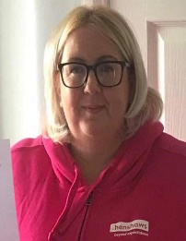
Mel Cooke
Community Services Manager, Children & Young People (CYP)
Email: mel.cooke@henshaws.org.uk
M: 0797 063 6802 T: 0300 222 5555
Claire Dawes
Oldham Enablement Officer Children & Young People (CYP)
Email: claire.dawes@henshaws.org.uk
M: 0777 563 0183 T: 0300 222 5555

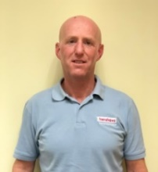
George Ferguson
Enablement Officer Children & Young People (CYP) Weekend Activities – Greater Manchester
Email: george.ferguson@henshaws.org.uk
M: 0797 063 7687 T: 0300 222 5555

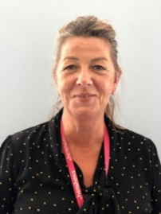
Marie Hansen
Enablement Officer Children & Young People (CYP)
Weekend Activities - Merseyside
Email: marie.hansen@henshaws.org.uk
M: 0773 421 3663 T: 0300 222 5555
Alice Osborne
Enablement Officer Children & Young People (CYP)
Email: alice.osborne@henshaws.org.uk
M: 0789 409 7633 T:0300 222 5555

