We are here for you
Spring 2022
We are a charity that helps people living with sight loss and a range of other disabilities go beyond expectations.
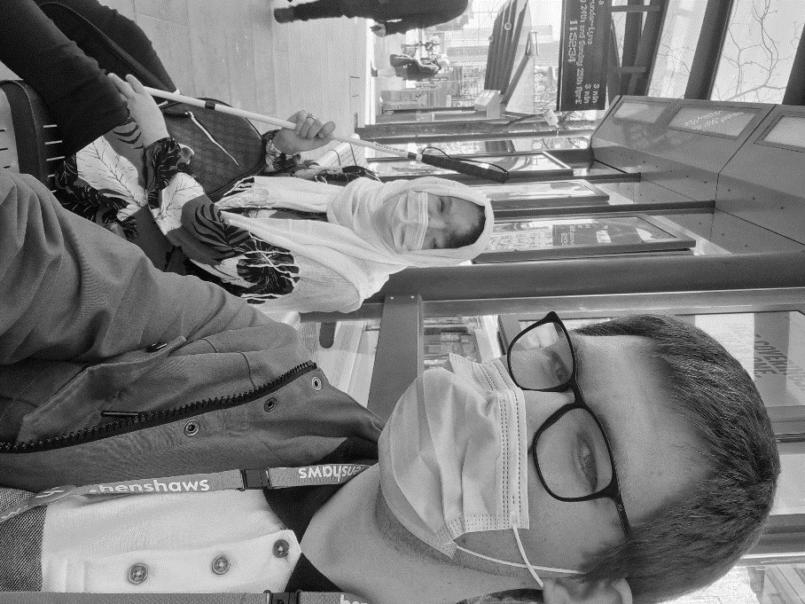
Henshaws, 4a Washbrook House, Lancastrian Office Centre, Talbot Road, Stretford, Manchester M32 0FP
Phone: 0300 222 5555 Visit: www.henshaws.org.uk
Contents
Page 2 Welcome back
Page 4 What’s been happening?
Page 7 Meet Charley
Page 7 Challenge yourself this summer
Page 8 Get in touch

Photograph on the front cover show our Manchester Enablement Officer Josh with a service user at a Metrolink Tram stop as part of our community programme.

Hello and welcome to our new update!

We know it’s been a while and we are happy to be back in touch with you. Since March 2020, our world has turned upside down as we all dealt with one of the most devastating health pandemics we have ever seen.

It has brought many changes, as we adapt to a new way of living and working. Henshaws is no different. We have adapted in new ways to provide the best possible advice and support for you. It also gave us the opportunity to visit how we were communicating with our service users and supporters. This newsletter is in a new format featuring our services as we share with you an update of our work supporting people with sight loss to go beyond expectations. - Tom Harte, Charity Director

If you would like to access the audio and digital version of this newsletter visit www.henshaws.org.uk/hello-newsletter/

Stay connected
Our website and social media channels have the latest
information on our activities, services, and resources.
Check out www.henshaws.org.uk for more information.

You can also receive fortnightly updates through our Knowledge Village email newsletter. Our Knowledge Village is a home for articles, videos, tips, tricks, and useful information.
Sign up by visiting www.henshaws.org.uk/mailing-list

Top tips-for this spring
Here Simon our Community Services Development Manager (First Step and Patient Support Lead) shares some tips as the season changes.
It’s spring and we’re all looking forward to getting out and about, I know I am, I can’t see much in the dark or dusk so I’m always raring to go in spring. We could still have some ice and rain so just keep in mind that it could be icy, plus the rain reduces contrast very quickly.
The weather is still picking up we’re not there yet, so don’t forget to wrap up warm, the wind is cutting and can cause a nasty distraction when you’re trying to think. I don’t like wearing a hood, I can’t hear the traffic, so remember to keep your ears out.
Take a backpack, you can always take an extra coat, or put your coat away, plus you can put all your gear and shopping in a backpack, keeping both hands free.
The sun is starting to get up in the sky, I always wear a peaked cap, it keeps the sun out of my face and eyes, the other thing I keep out of my line of sight is the good old British spring sky, bright white and dazzling.
Lighting is a big factor, yes, it is staying light longer but, don’t get caught out, it still goes dark quickly, so keep note of the time. If you’re travelling on public transport, remember you’ll be getting into peak travel times.
Plan ahead, if you’ve not been out in a while have a plan, if you’re not sure, ask a friend to go with you, as we all know it gets complicated navigating and keeping track of what’s going on sometimes.
It’s worth checking with public transport what’s going on, there’s plenty of upgrades going on so check before you travel.
Our services-What’s been happening?
First Step IAG (Information Advice and Guidance) are now back in the office full time and waiting to take your call. The team will work with you to find the best service and support to help you go beyond expectations. If you’re not sure which way to turn or would like some information about sight loss or Henshaws services, give us a call and let us help.

First Step Patient Support are back in Manchester Royal Eye Hospital Monday to Friday, and Altrincham Hospital every Tuesday. We are here to support you in the hospitals or over the phone. We are working with extra safety measures and are keen to keep everyone accessing the service safe. So, we may meet you in the hospital for a quick chat but call you back for a longer conversation.

We also now have a new CVI team. Which is a collaboration between Henshaws and Manchester Royal Eye Hospital. The team ensures that all people who receive a certificate of vision impairment have access to the relevant services. We are ensuring that people receive support at the earliest possible time, explaining the certificate, the process, helping people understand their eye condition and its implications. This supports patients being better informed about their condition, understanding their options, improving emotional wellbeing, independence, and confidence.

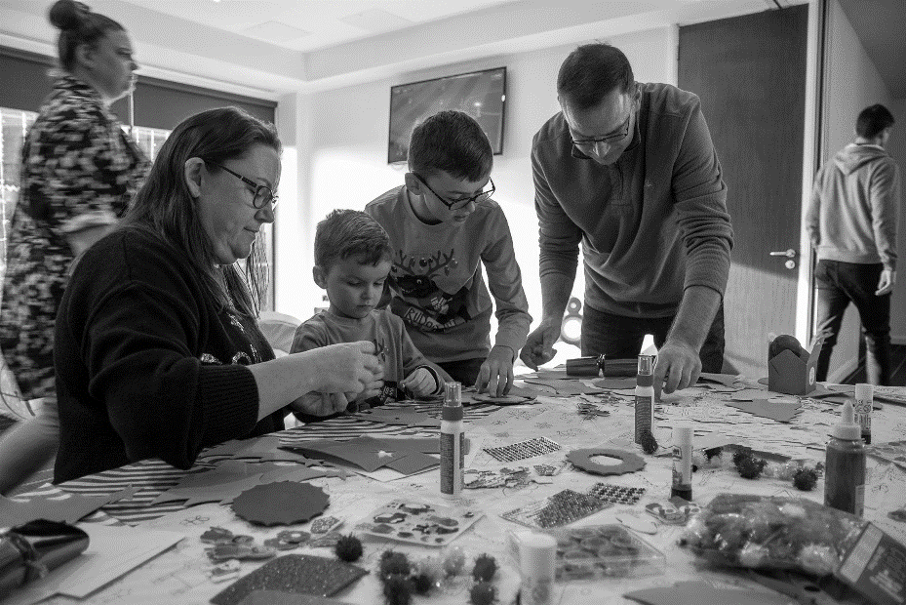
Photograph above is of children and adults enjoying arts and crafts together at a recent event.
We are welcoming Children, young people, and their families back to face-to-face activities and running virtual sessions too.
We have successfully delivered our highly anticipated I Can Do It course in February half term. Places were fully booked, and everyone had a great time despite the wet weather! We also continue to engage with all our existing families to make sure they are being supported and looking for opportunities to meet new families to support.
The Digital Enablement team, during the various lockdown periods we were busier than ever as more people needed support to use technology than ever before. In 2020/21 across Greater Manchester, we supported over a 1000 people! We have worked hard to keep people connected so that everyday tasks like reading, writing, keeping in touch with their friends and family, not just in the traditional way but through video too was made possible. We also helped people get ‘on-line’ so they could keep track of their medication, prescriptions, manage medical appointments and have their supermarket shopping delivered to their homes. We are back at all our hubs now, Bolton, Oldham, Stretford, Sale, Tameside and Manchester Central Library. Get in touch for your free digital assessment today!
From time to time, new technology comes our way, and we are really excited about a device called the OxSight Onyx, which is set to help people with central vision loss. If you want to know more, please get in touch.
The Enablement team have been working hard across Bolton, Tameside, Manchester, Oldham, Salford and Trafford delivering one to one support, information and peer support courses and facilitating friendship matters groups to keep those who need our help informed and up to date. Our sessions are in person at one of our hubs or can be over the phone or video. We have worked with hundreds of people throughout the Covid-19 pandemic offering tailored advice and support. Recently we have begun to write blogs on opening our hubs safely and letting people know what groups we have on offer. Give us a call to find out more or visit our website.

If you would like information about our up-and-coming courses, please do get in touch.

Henshaws Knowledge Village
Henshaws Knowledge Village continues to grow with new content, including recent videos about filters and tints, magnifiers, and dictation solutions. We also publish three blogs each month on our website, on topics such as new apps and technology, top tips to help when you are out and about, and guest blogs by people within the sight loss community.
Please make sure you visit our Knowledge Village to explore our valuable resources at www.henshaws.org.uk/knowledge-village You can also subscribe to our YouTube channel at www.youtube.com/user/Henshaws1837 where we release a new video every Wednesday.
If you would like to receive fortnightly e-mails so you can keep up to date with new content on our Knowledge Village, make sure you join our mailing list through the website at www.henshaws.org.uk/sign-up-knowledge-village
Charley’s journey
Charley’s mum first contacted Henshaws as she was struggling in school to see the teachers board and to read text. She had been to the hospital and had some tests, but they showed no medical reason for her sight loss and had to patiently wait for a referral to paediatrics. Charley’s mum desperately wanted support at school for her daughter so she could access education. As there wasn’t a diagnosis, the school was limited to what they could do. Charley and mum met with Henshaws who carried out an assessment for which advice and support was provided. This included things that are easy to resolve that people might not consider such as ideal font size to use, a filter to put over text, the best lighting, free and safe apps that can be used on Charley’s iPad and information on what they should expect from the school, the QTVI (Qualified Teacher of Children and Young People with Vision Impairment) and the local authority. Charley left feeling empowered and with these immediate fixes to the difficulties she was facing. Unfortunately, school were not able to provide Charley with the equipment she needed so she still struggled at school but was able to complete tasks at home much more easily. Henshaws was able to offer her family funding due to the kind donations from our supporters to provide an electronic device that Charley can take into school with her to help with her learning. Charley is feeling much more confident that with continued support from Henshaws and its supporters that she can go beyond expectations.

Trafford Fundraising Luncheon Club

Fancy fundraising for Henshaws by eating a delicious 3-course meal and meeting friends? Join the Luncheon club once a month at Trafford College’s Aspire Restaurant. If you would like to know more, please contact kat.parry@henshaws.org.uk

Challenge accepted!

Take on a challenge for Henshaws. Walk the Yorkshire Three Peaks in 12 hours. Run the TCS London Marathon. Run the Great North Run. If you or any friends or family wish to take on a challenge whilst raising money for Henshaws, give Kat Parry in fundraising a call on 07970 638 175 or visit our website.
Having people take part in these challenges really does help raise essential funds to keep our services free to people who need it most as much as possible.

Contact Henshaws: Tel 0300 222 5555
Email info@henshaws.org.uk
Web www.henshaws.org.uk

Disclaimer- Although every attempt is made to ensure that the information contained within this newsletter is timely and accurate, Henshaws cannot be held responsible for any information herein. This newsletter is provided for information purposes only and is not intended to be either legally binding or contractual in nature.

